# Broken Links Report

• Broken link on <https://www.utep.edu/cs/main-menu/calendar.html> on **Main Content (Top small navigation)** section, the broken link is displayed as: **Resources** and the link is pointing to : <https://www.utep.edu/cs/main-menu/>

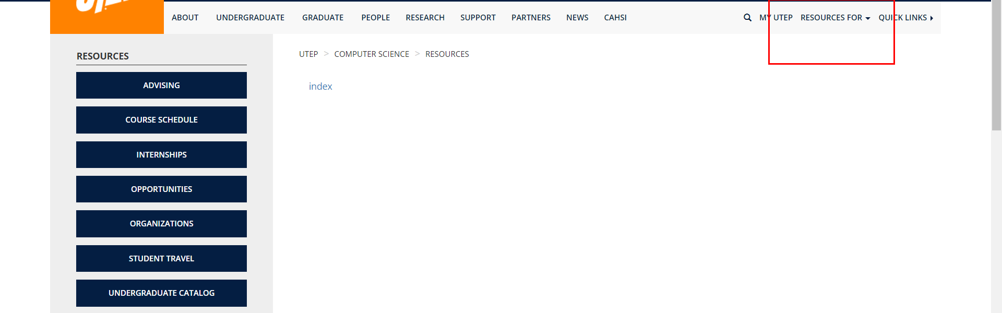

• Broken link on <https://www.utep.edu/cs/main-menu/Join-CS.html> on **Main Navigation, tab name: About Us** section, the broken link is displayed as: **Computing Facilities** and the link is pointing to : <https://www.utep.edu/cs/about/computingFacilities.html>

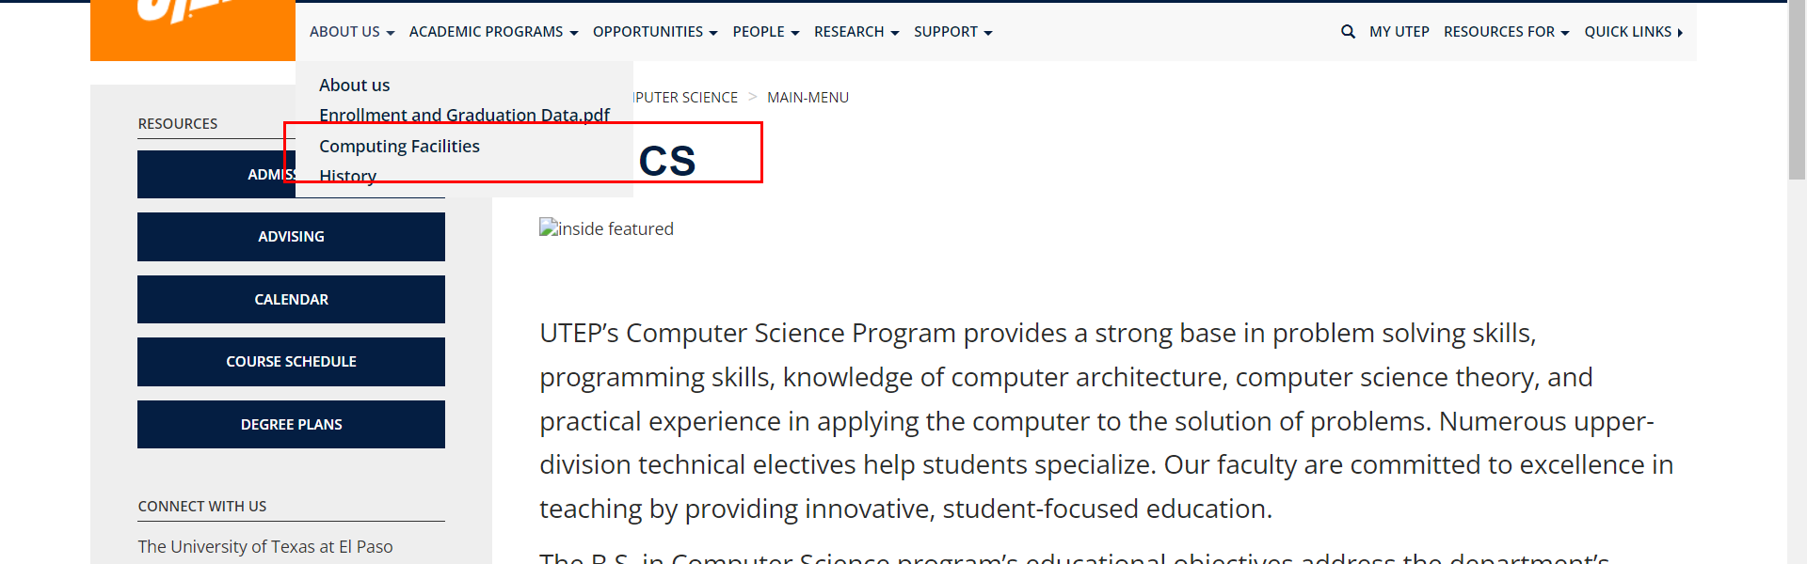

• Broken link on <https://www.utep.edu/cs/main-menu/Join-CS.html> on **Main Navigation, tab name: Academic Programs** section, the broken link is displayed as: **Master's Thesis Template** and the link is pointing to : <https://www.utep.edu/cs/academic/MastersThesisTemplate.html>

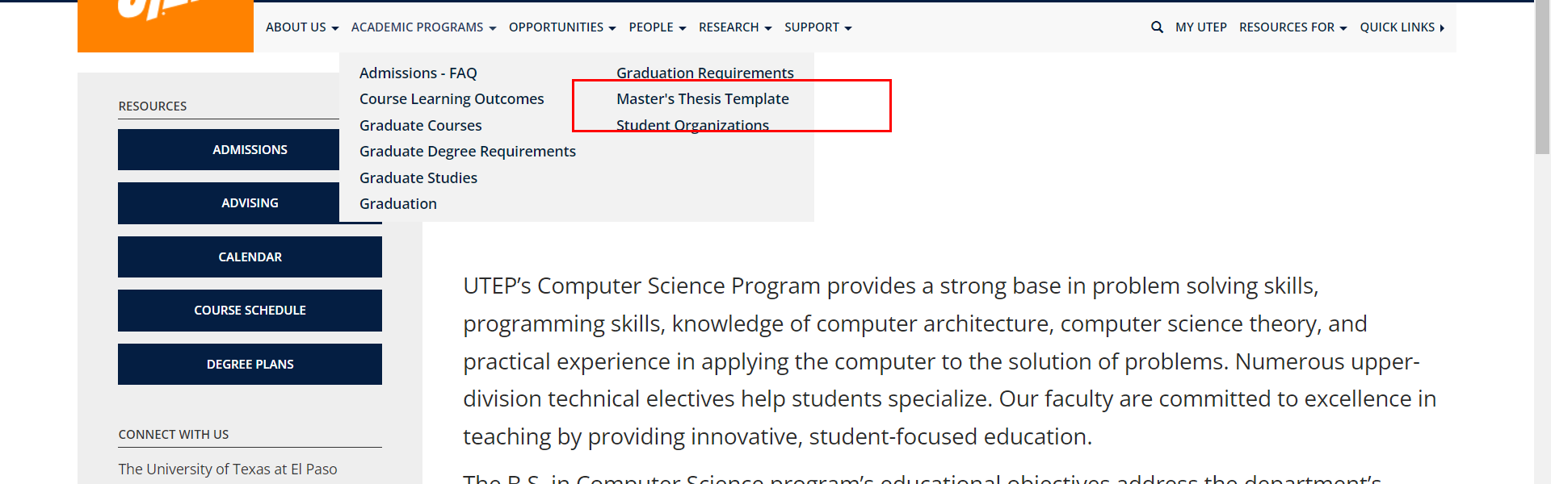

• Broken link on <https://www.utep.edu/cs/main-menu/Join-CS.html> on **Main Navigation, tab name: Academic Programs** section, the broken link is displayed as: **Course Learning Outcomes** and the link is pointing to : <https://www.utep.edu/cs/academic/CourseLearningOutcomes.html>

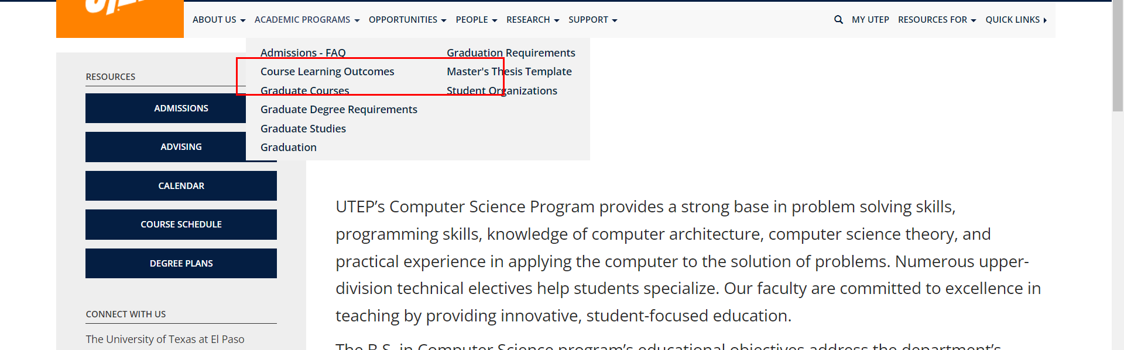

• Broken link on <https://www.utep.edu/cs/main-menu/Join-CS.html> on **Main Navigation, tab name: People** section, the broken link is displayed as: **Teacher Assistants** and the link is pointing to : <https://www.utep.edu/cs/people/teaching-assistant.html>

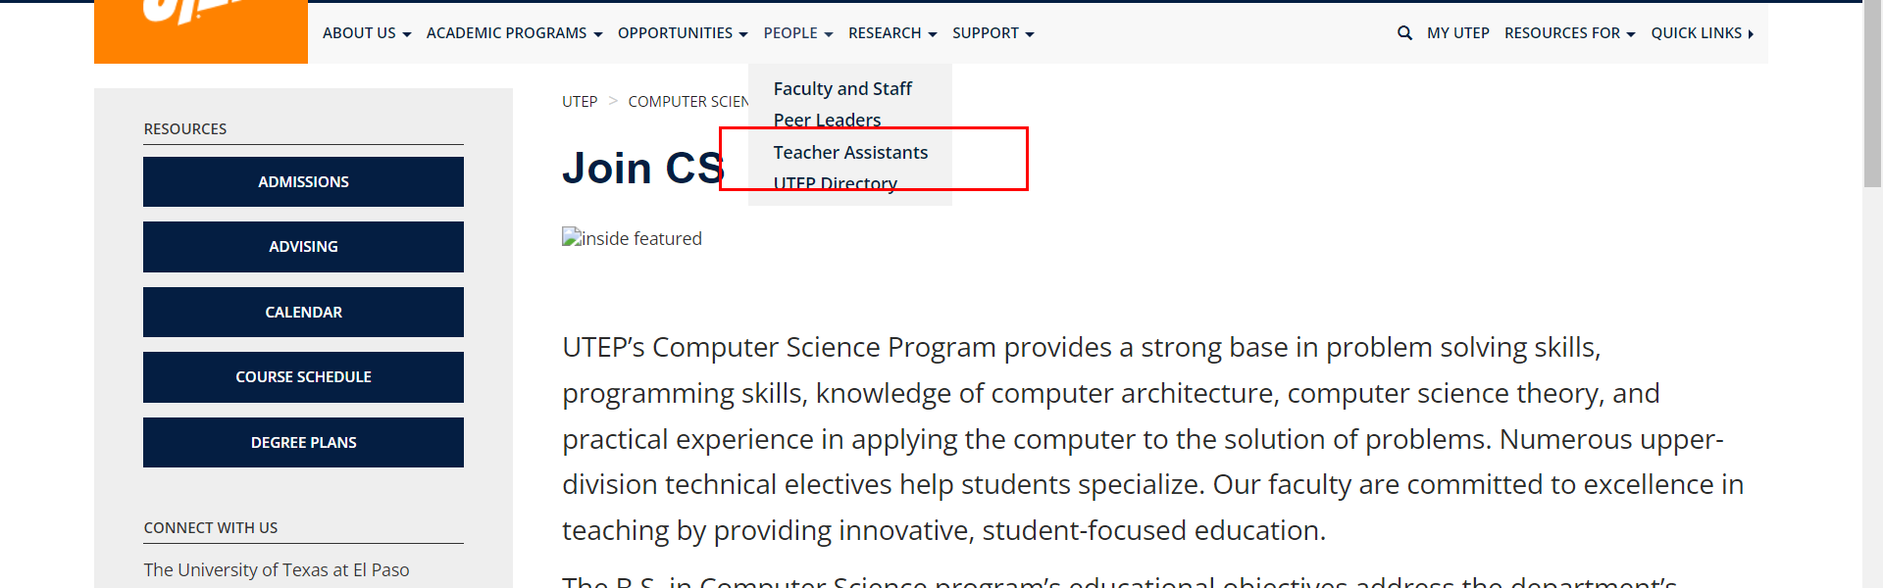

• Broken link on <https://www.utep.edu/cs/main-menu/Join-CS.html> on **Main Navigation, tab name: Opportunities** section, the broken link is displayed as: **Scholarships and Interships** and the link is pointing to : <https://www.utep.edu/cs/Opportunities/Scholarships%20and%20Interships.html>

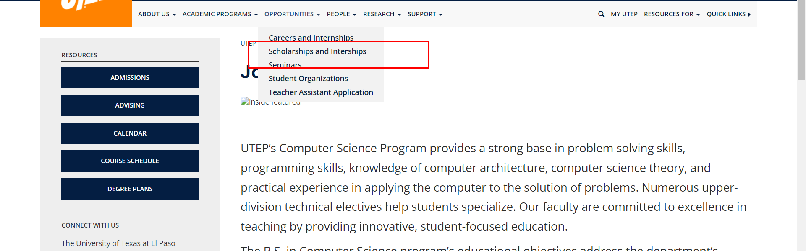

• Broken link on <https://www.utep.edu/cs/main-menu/Join-CS.html> on **Main Navigation, tab name: Academic Programs** section, the broken link is displayed as: **Graduate Studies** and the link is pointing to : <https://www.utep.edu/cs/academic/GraduateStudies.html>

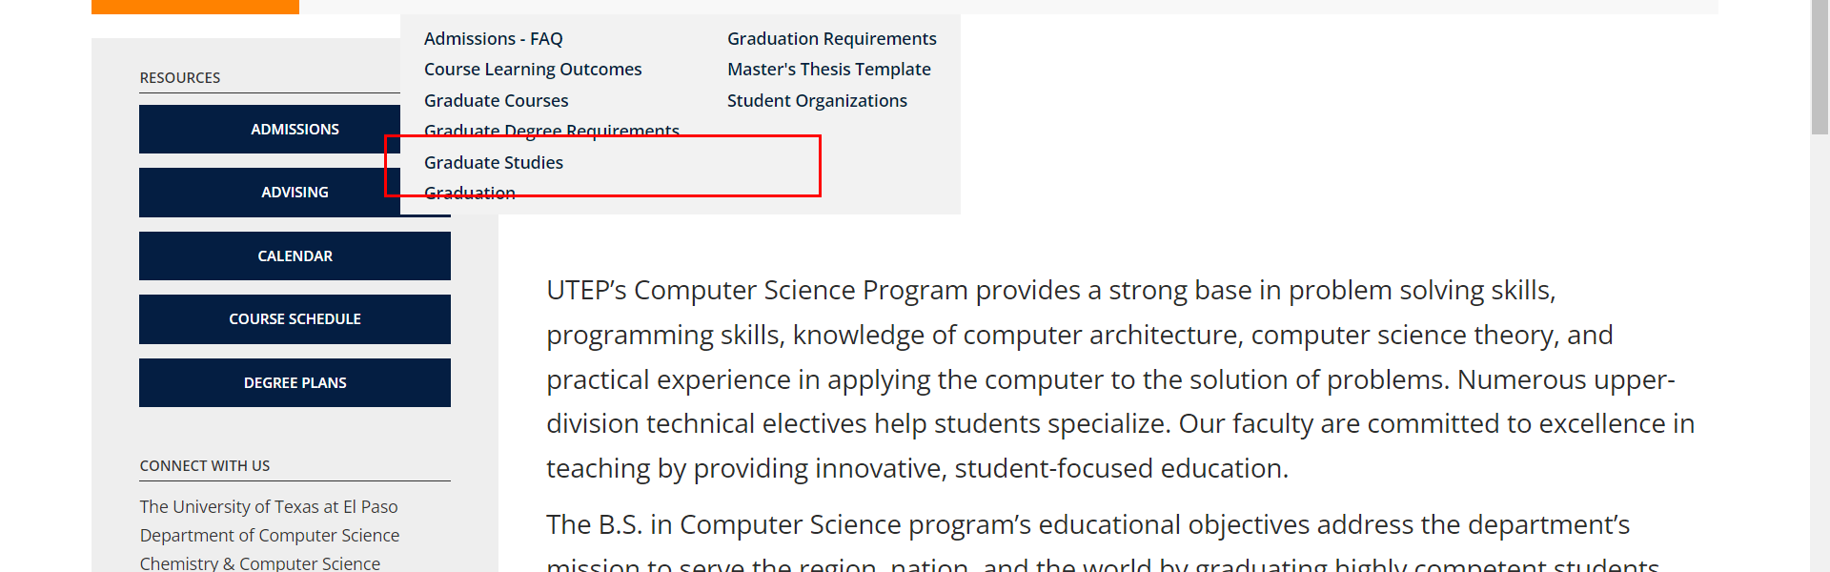

• Broken link on <https://www.utep.edu/cs/main-menu/Join-CS.html> on **Main Navigation, tab name: Academic Programs** section, the broken link is displayed as: **Admissions - FAQ** and the link is pointing to : <https://www.utep.edu/cs/academic/AdmissionsFAQ.html>

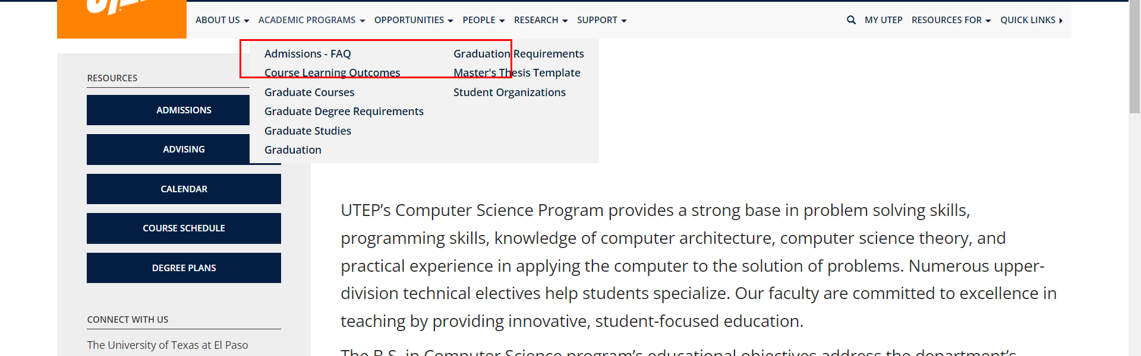

• Broken link on <https://www.utep.edu/cs/main-menu/Join-CS.html> on **Main Navigation, tab name: Academic Programs** section, the broken link is displayed as: **Student Organizations** and the link is pointing to : <https://www.utep.edu/cs/academic/StudentOrganizations.html>

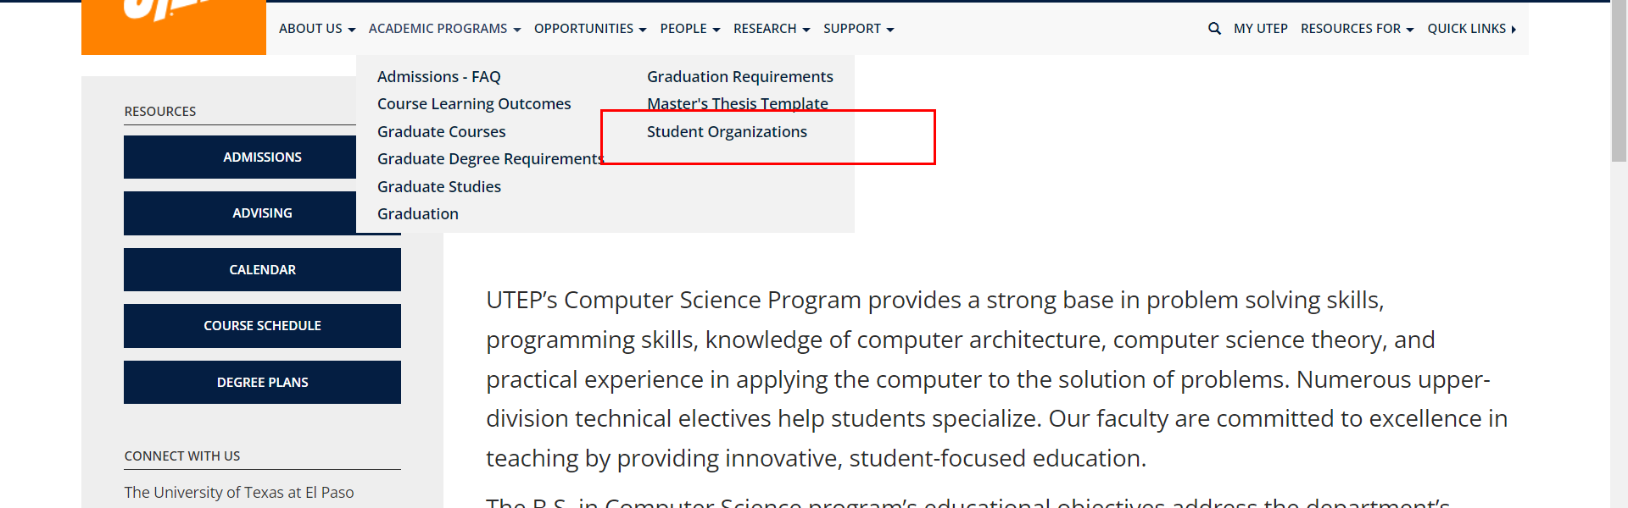

• Broken link on <https://www.utep.edu/cs/main-menu/Join-CS.html> on **Main Navigation, tab name: Academic Programs** section, the broken link is displayed as: **Graduation Requirements** and the link is pointing to : <https://www.utep.edu/cs/academic/GraduationRequirements.html>

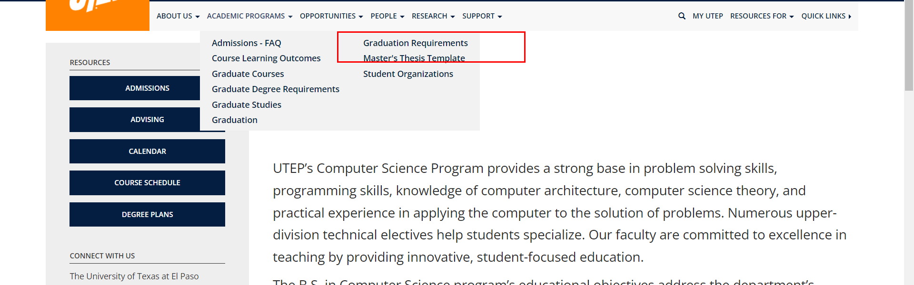

• Broken link on <https://www.utep.edu/cs/main-menu/Join-CS.html> on **Main Navigation, tab name: Support** section, the broken link is displayed as: **Research Labs Support** and the link is pointing to : <https://www.utep.edu/cs/main-menu/Web%20Related.html>

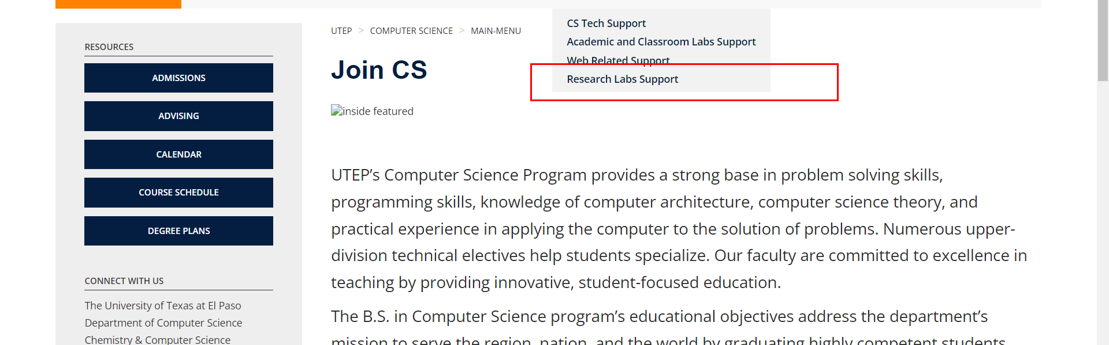

• Broken link on <https://www.utep.edu/cs/main-menu/Join-CS.html> on **Main Navigation, tab name: Opportunities** section, the broken link is displayed as: **Careers and Internships** and the link is pointing to : <https://www.utep.edu/cs/Opportunities/CareersInternships.html>

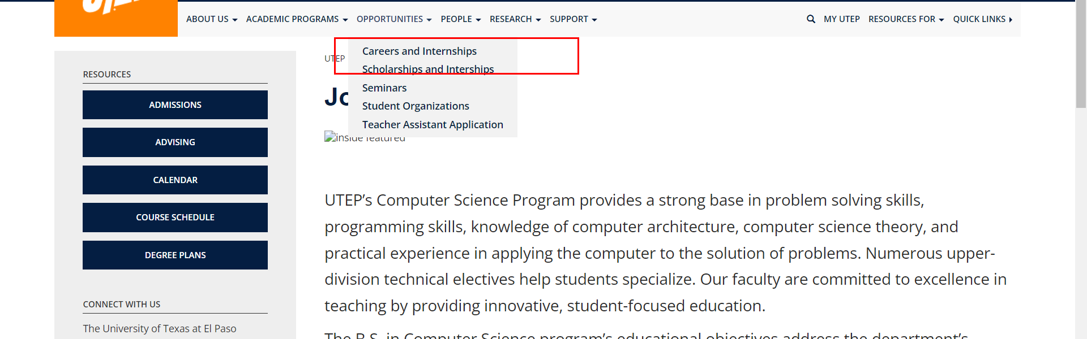

• Broken link on <https://www.utep.edu/cs/main-menu/Join-CS.html> on **Main Navigation, tab name: People** section, the broken link is displayed as: **Peer Leaders** and the link is pointing to : <https://www.utep.edu/cs/people/PeerLeaders.html>

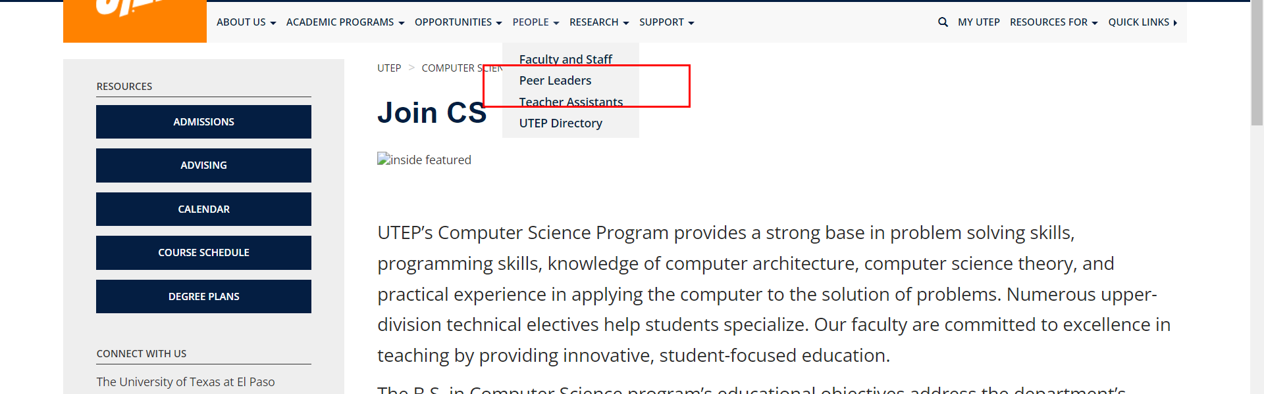

• Broken link on <https://www.utep.edu/cs/main-menu/Join-CS.html> on **Main Navigation, tab name: Research** section, the broken link is displayed as: **Research Centers** and the link is pointing to : <https://www.utep.edu/cs/Research/Research_Centers.html>

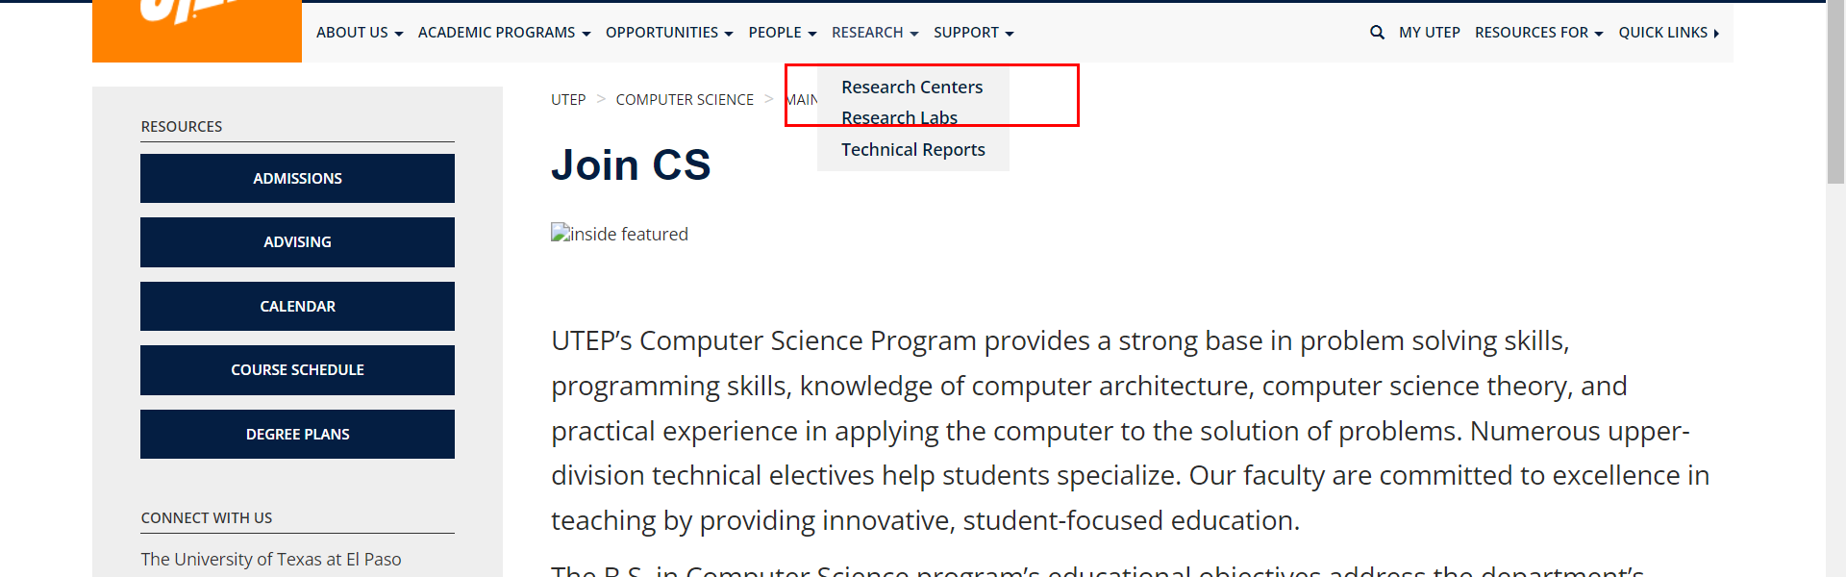

• Broken link on <https://www.utep.edu/cs/main-menu/Join-CS.html> on **Main Navigation, tab name: About Us** section, the broken link is displayed as: **Enrollment and Graduation Data.pdf** and the link is pointing to : <https://www.utep.edu/cs/about/Enrollment%20and%20Graduation%20Data.pdf>

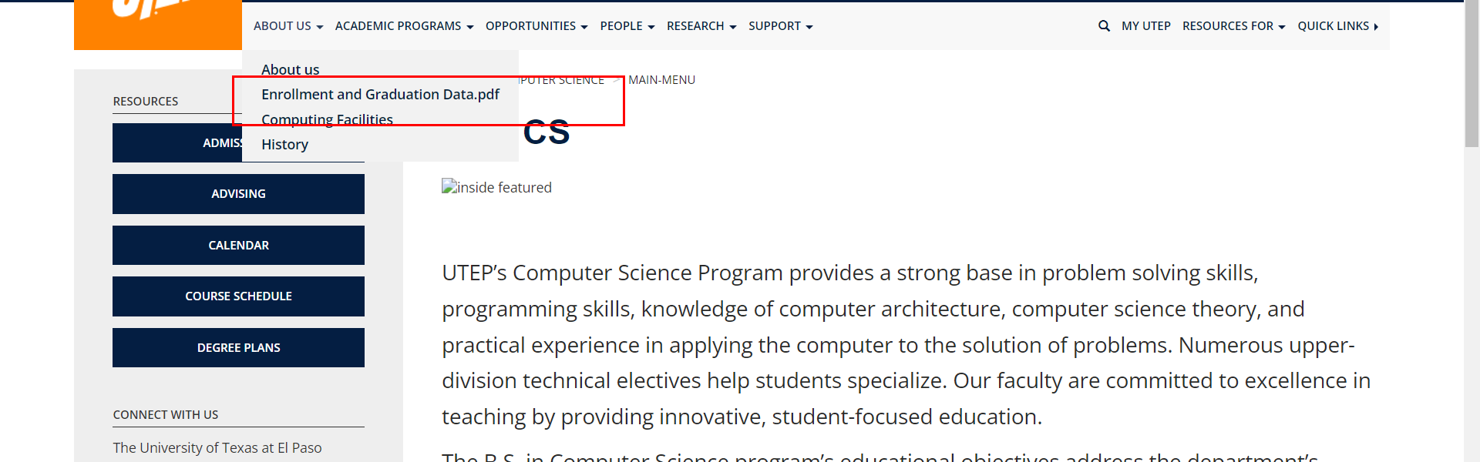

• Broken link on <https://www.utep.edu/cs/main-menu/Join-CS.html> on **Main Navigation, tab name: Academic Programs** section, the broken link is displayed as: **Graduation** and the link is pointing to : <https://www.utep.edu/cs/academic/Graduation.html>

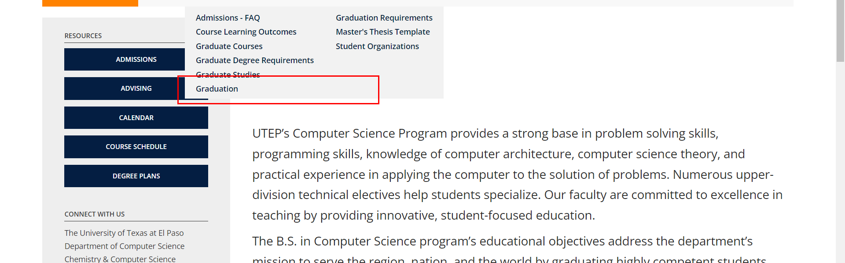

• Broken link on <https://www.utep.edu/cs/main-menu/Join-CS.html> on **Main Navigation, tab name: Support** section, the broken link is displayed as: **Academic and Classroom Labs Support** and the link is pointing to : <https://www.utep.edu/cs/main-menu/Academic%20and%20Classroom%20Labs.html>

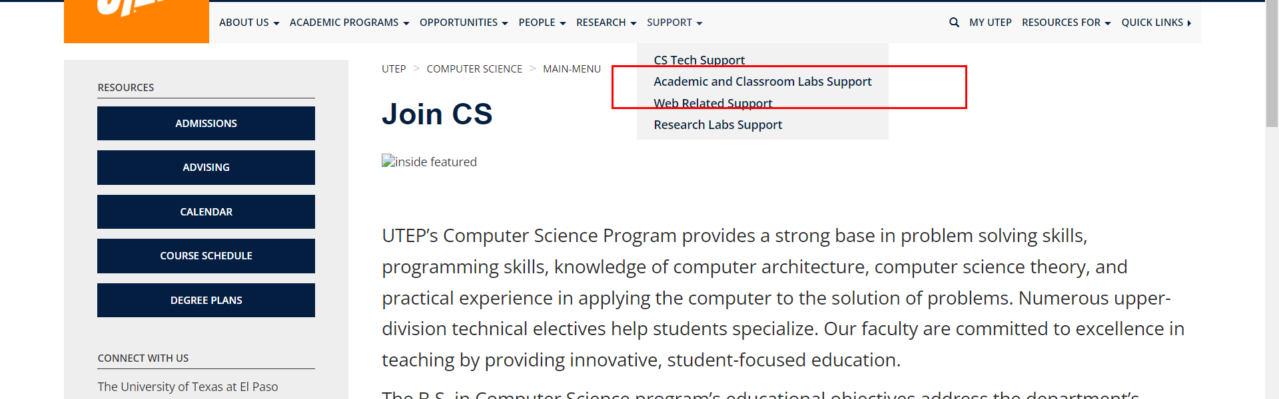

• Broken link on <https://www.utep.edu/cs/main-menu/Join-CS.html> on **Main Navigation, tab name: Support** section, the broken link is displayed as: **CS Tech Support** and the link is pointing to : <https://www.utep.edu/cs/main-menu/Support.html>

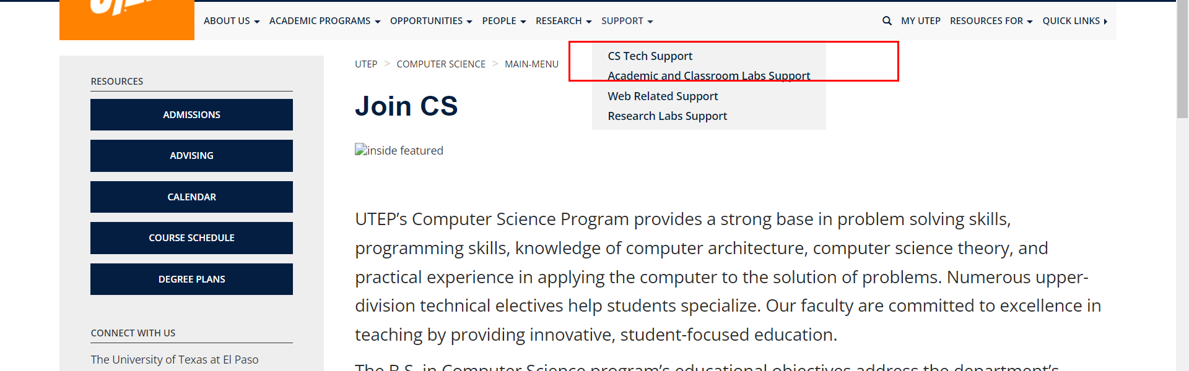

• Broken link on <https://www.utep.edu/cs/main-menu/Join-CS.html> on **Main Navigation, tab name: Opportunities** section, the broken link is displayed as: **Seminars** and the link is pointing to : <https://www.utep.edu/cs/Opportunities/Seminars.html>

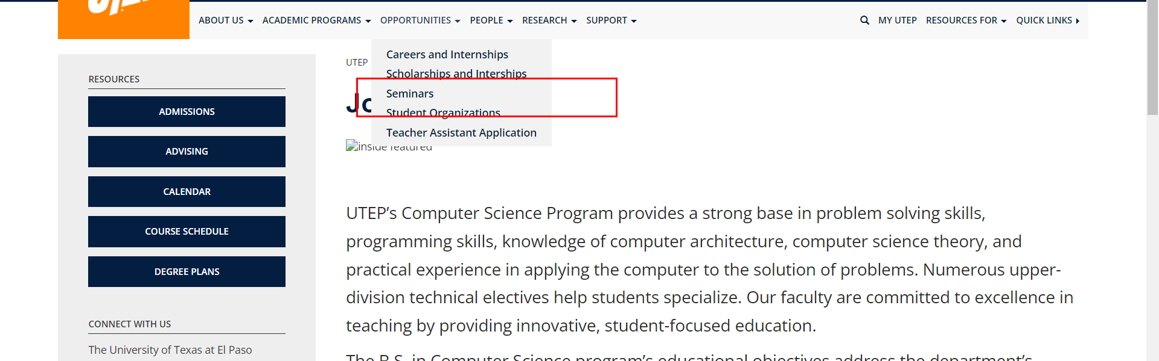

• Broken link on <https://www.utep.edu/cs/main-menu/Join-CS.html> on **Main Content (Top small navigation)** section, the broken link is displayed as: **Main-menu** and the link is pointing to : <https://www.utep.edu/cs/Main-menu/>

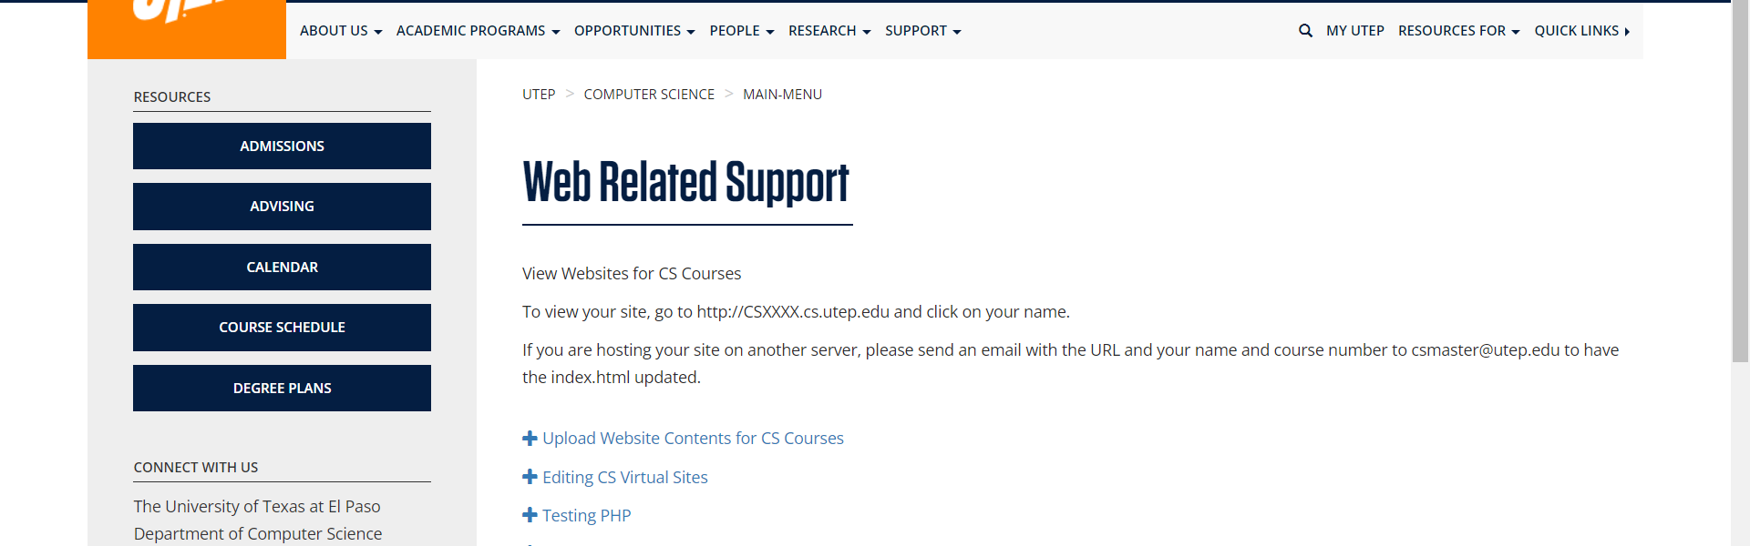

• Broken link on <https://www.utep.edu/cs/main-menu/Join-CS.html> on **Left Navigation** section, the broken link is displayed as: **Calendar** and the link is pointing to : <https://www.utep.edu/cs/Opportunities/calendar.html>

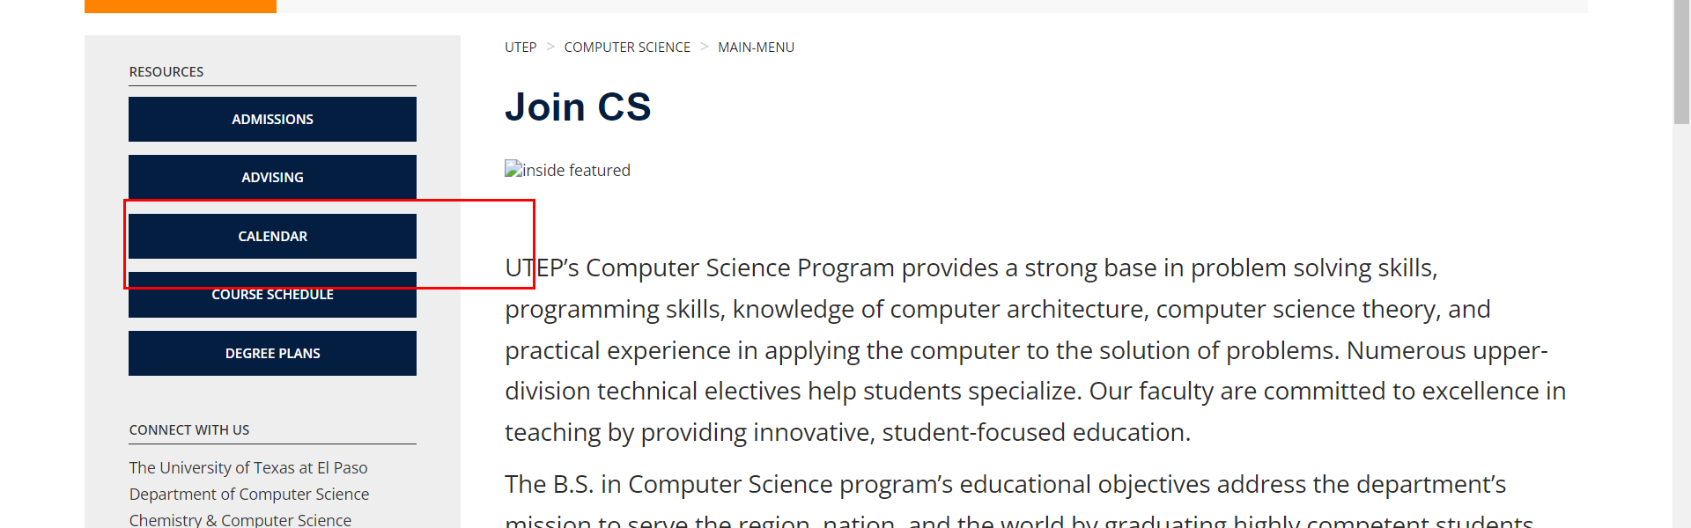

• Broken link on <https://www.utep.edu/cs/main-menu/Join-CS.html> on **Left Navigation** section, the broken link is displayed as: **Admissions** and the link is pointing to : <https://www.utep.edu/cs/main-menu/Admissions.html>

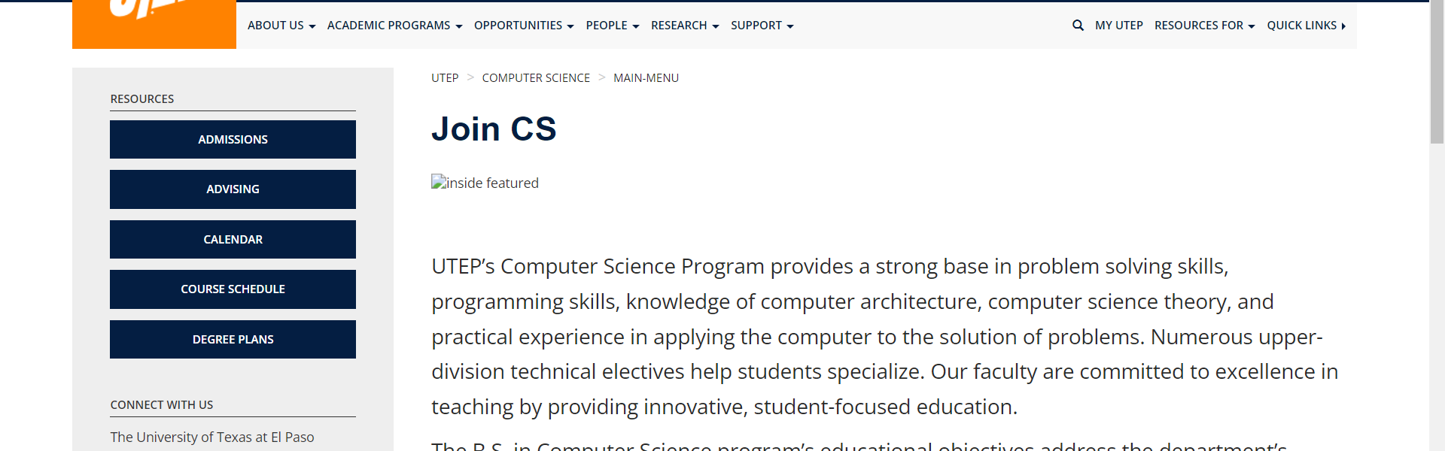

• Broken link on <https://www.utep.edu/cs/main-menu/Join-CS.html> on **Left Navigation** section, the broken link is displayed as: **Advising** and the link is pointing to : <https://www.utep.edu/cs/main-menu/Advising.html>

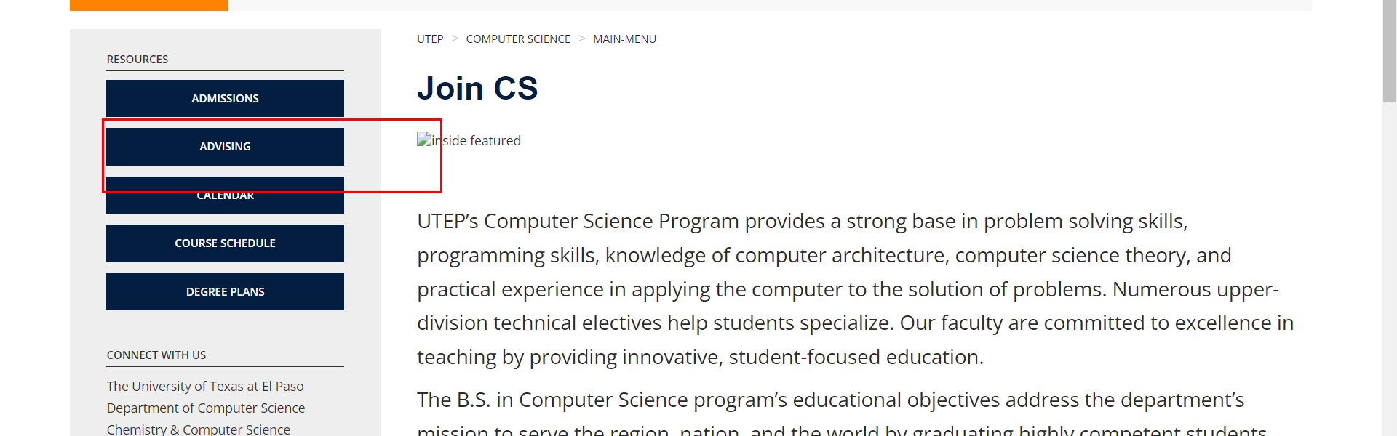

• Broken link on <https://www.utep.edu/cs/main-menu/Join-CS.html> on **Left Navigation** section, the broken link is displayed as: **Degree Plans** and the link is pointing to : <https://www.utep.edu/cs/main-menu/DegreePlans.html>

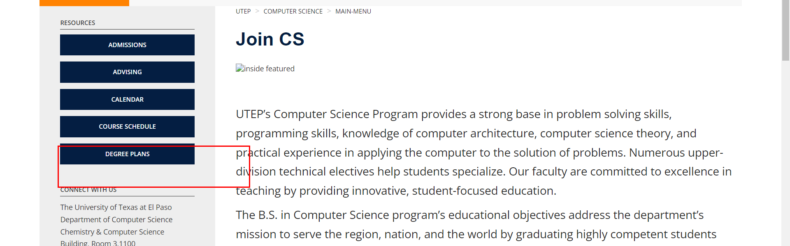

• Broken link on <https://www.utep.edu/cs/main-menu/Join-CS.html> on **Left Navigation** section, the broken link is displayed as: **Course Schedule** and the link is pointing to : <https://www.utep.edu/cs/main-menu/CourseSchedule.html>

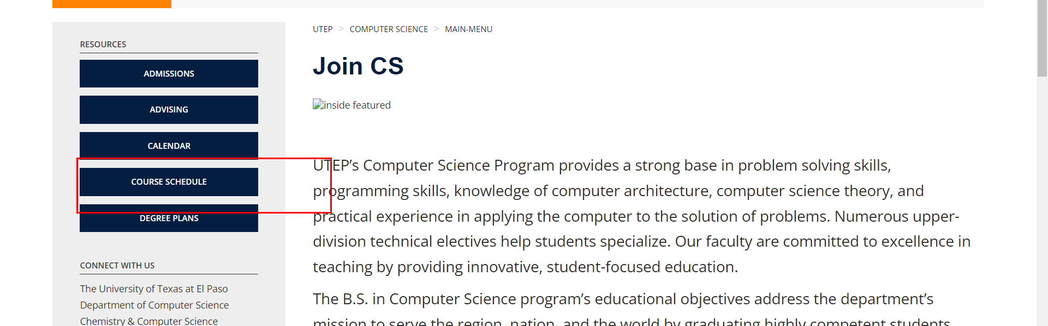

• Broken link on <https://www.utep.edu/cs/main-menu/Research.html> on **Main Navigation, tab name: Academic Programs** section, the broken link is displayed as: **Graduation** and the link is pointing to : <https://www.utep.edu/cs/academic/Graduation.html>

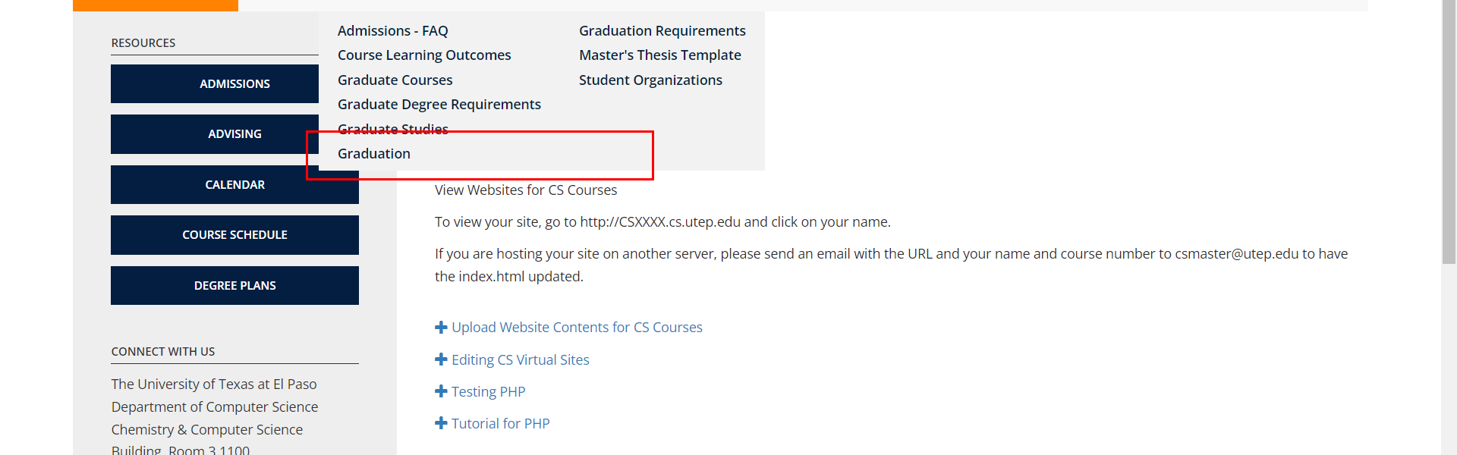

• Broken link on <https://www.utep.edu/cs/main-menu/Research.html> on **Main Navigation, tab name: Academic Programs** section, the broken link is displayed as: **Student Organizations** and the link is pointing to : <https://www.utep.edu/cs/academic/StudentOrganizations.html>

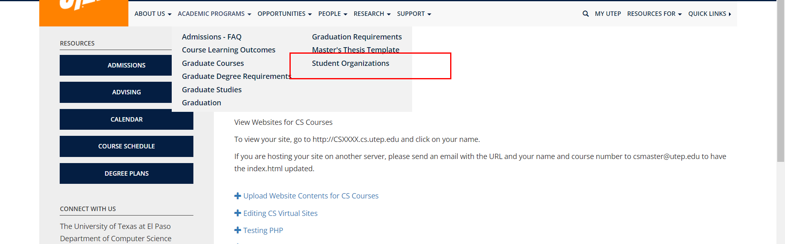

• Broken link on <https://www.utep.edu/cs/main-menu/Research.html> on **Main Navigation, tab name: Opportunities** section, the broken link is displayed as: **Seminars** and the link is pointing to : <https://www.utep.edu/cs/Opportunities/Seminars.html>

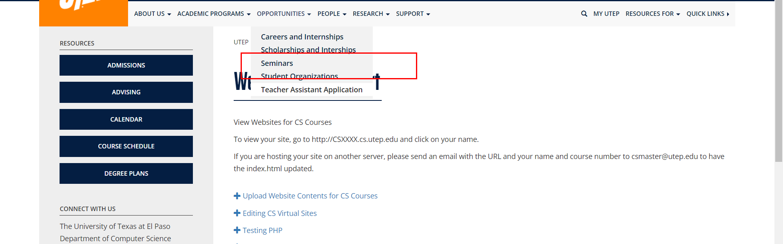

• Broken link on <https://www.utep.edu/cs/main-menu/Research.html> on **Main Navigation, tab name: About Us** section, the broken link is displayed as: **Enrollment and Graduation Data.pdf** and the link is pointing to : <https://www.utep.edu/cs/about/Enrollment%20and%20Graduation%20Data.pdf>

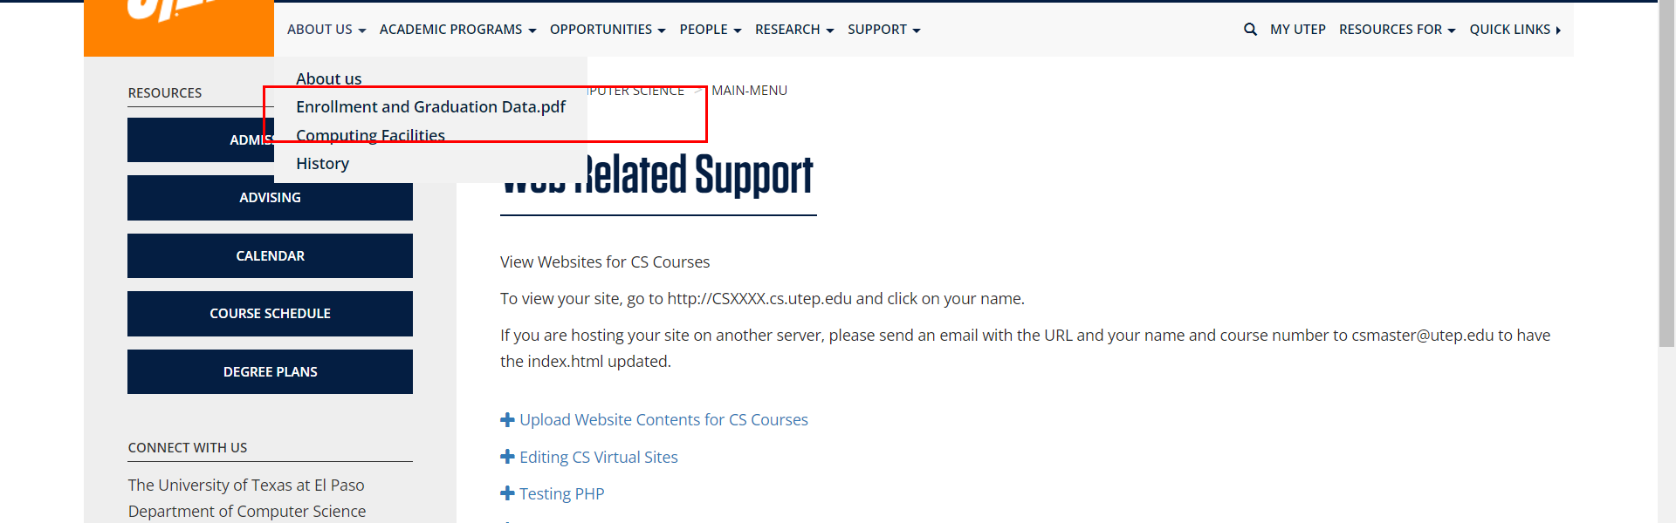

• Broken link on <https://www.utep.edu/cs/main-menu/Research.html> on **Main Navigation, tab name: Academic Programs** section, the broken link is displayed as: **Master's Thesis Template** and the link is pointing to : <https://www.utep.edu/cs/academic/MastersThesisTemplate.html>

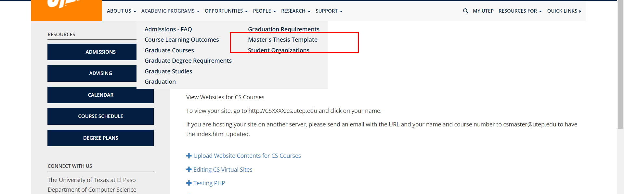

• Broken link on <https://www.utep.edu/cs/main-menu/Research.html> on **Main Navigation, tab name: About Us** section, the broken link is displayed as: **Computing Facilities** and the link is pointing to : <https://www.utep.edu/cs/about/computingFacilities.html>

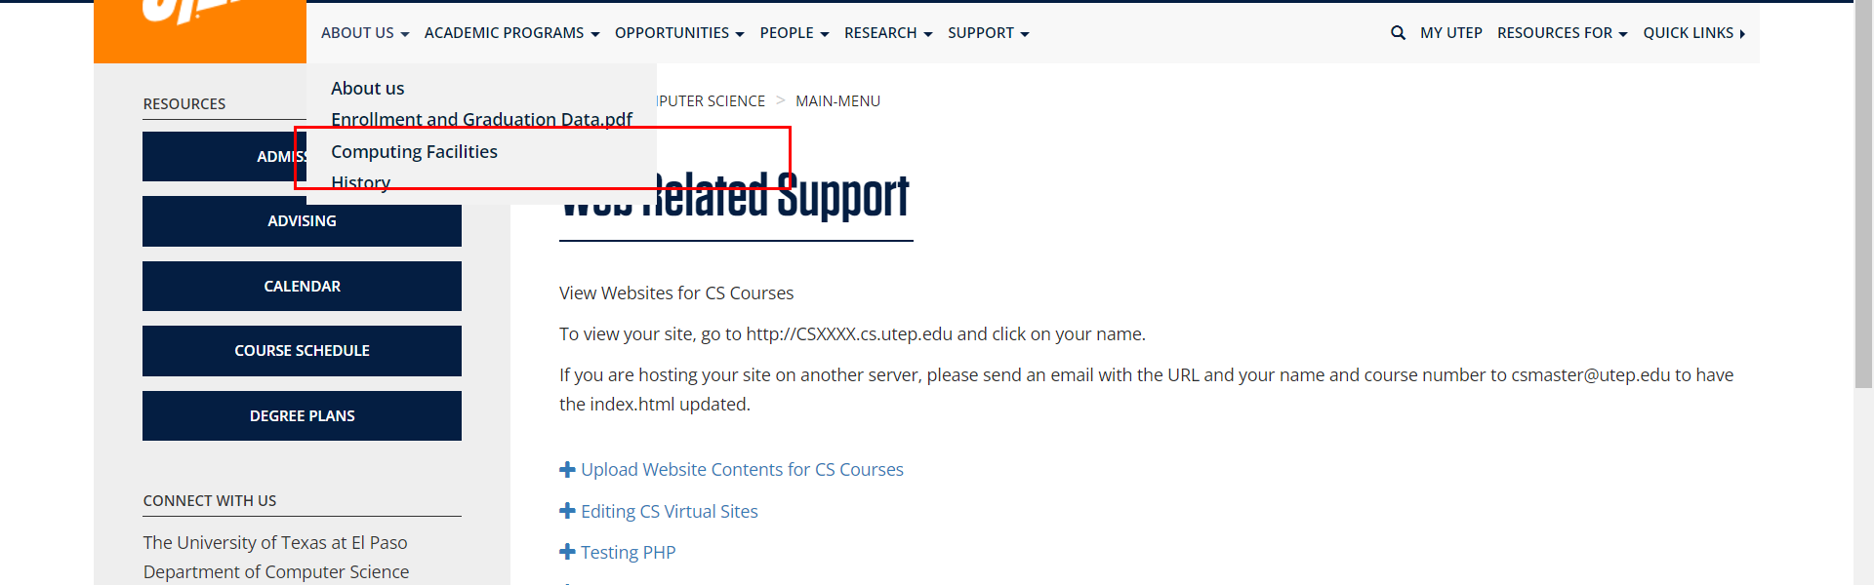

• Broken link on <https://www.utep.edu/cs/main-menu/Research.html> on **Main Navigation, tab name: Academic Programs** section, the broken link is displayed as: **Graduate Studies** and the link is pointing to : <https://www.utep.edu/cs/academic/GraduateStudies.html>

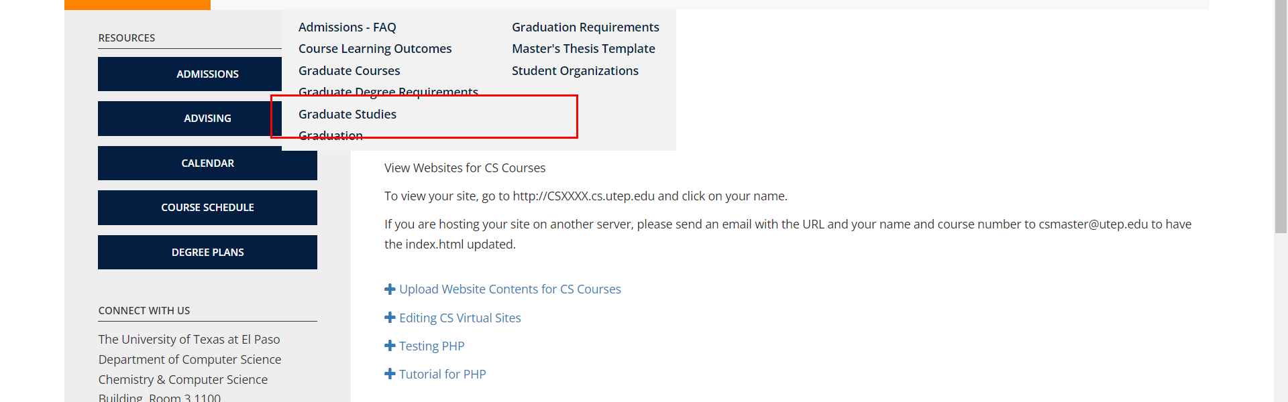

• Broken link on <https://www.utep.edu/cs/main-menu/Research.html> on **Main Navigation, tab name: Academic Programs** section, the broken link is displayed as: **Course Learning Outcomes** and the link is pointing to : <https://www.utep.edu/cs/academic/CourseLearningOutcomes.html>

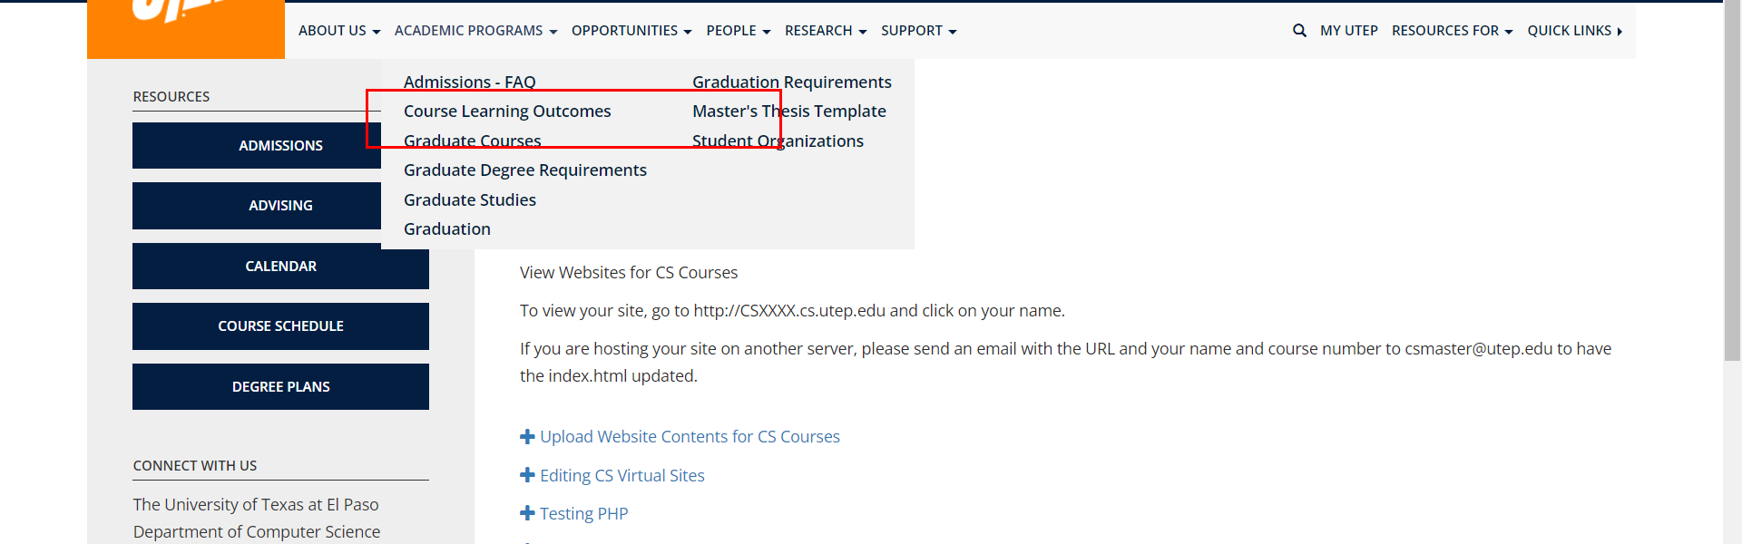

• Broken link on <https://www.utep.edu/cs/main-menu/Research.html> on **Main Navigation, tab name: Opportunities** section, the broken link is displayed as: **Careers and Internships** and the link is pointing to : <https://www.utep.edu/cs/Opportunities/CareersInternships.html>

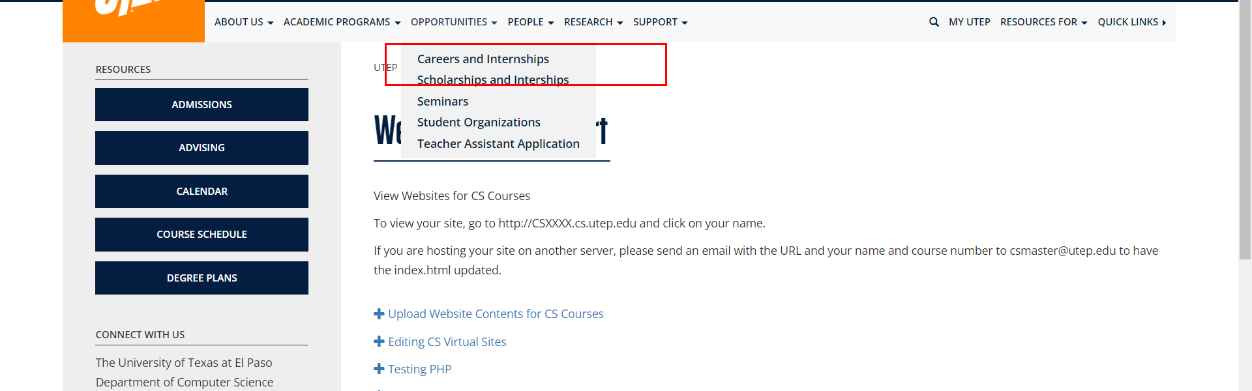

• Broken link on <https://www.utep.edu/cs/main-menu/Research.html> on **Main Navigation, tab name: Academic Programs** section, the broken link is displayed as: **Admissions - FAQ** and the link is pointing to : <https://www.utep.edu/cs/academic/AdmissionsFAQ.html>

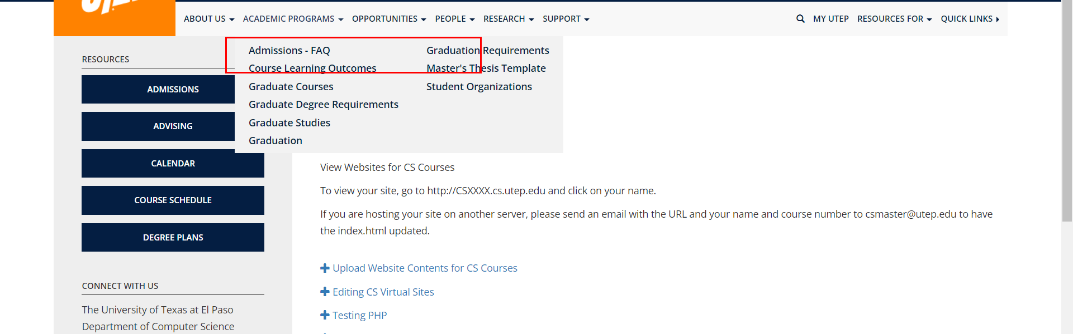

• Broken link on <https://www.utep.edu/cs/main-menu/Research.html> on **Main Navigation, tab name: Opportunities** section, the broken link is displayed as: **Scholarships and Interships** and the link is pointing to : <https://www.utep.edu/cs/Opportunities/Scholarships%20and%20Interships.html>

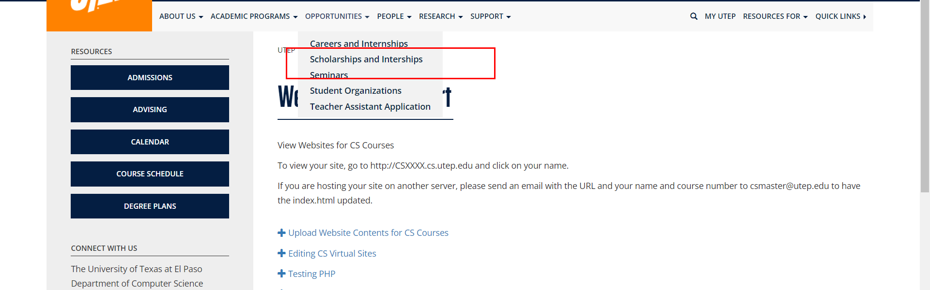

• Broken link on <https://www.utep.edu/cs/main-menu/Research.html> on **Main Navigation, tab name: Support** section, the broken link is displayed as: **CS Tech Support** and the link is pointing to : <https://www.utep.edu/cs/main-menu/Support.html>

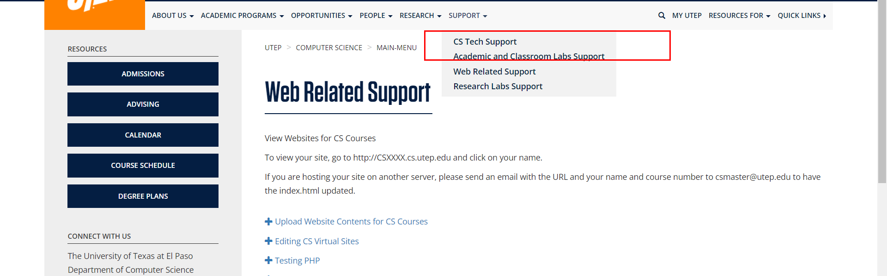

• Broken link on <https://www.utep.edu/cs/main-menu/Research.html> on **Main Navigation, tab name: Academic Programs** section, the broken link is displayed as: **Graduation Requirements** and the link is pointing to : <https://www.utep.edu/cs/academic/GraduationRequirements.html>

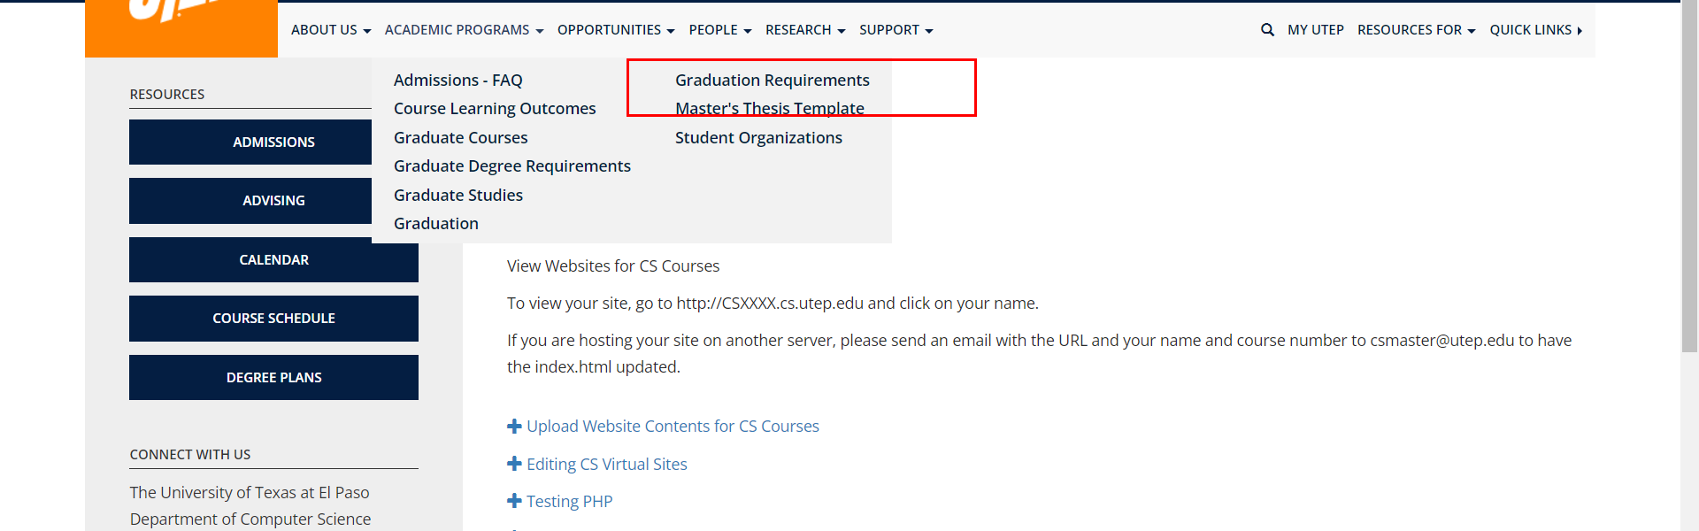

• Broken link on <https://www.utep.edu/cs/main-menu/Research.html> on **Main Navigation, tab name: Support** section, the broken link is displayed as: **Academic and Classroom Labs Support** and the link is pointing to : <https://www.utep.edu/cs/main-menu/Academic%20and%20Classroom%20Labs.html>

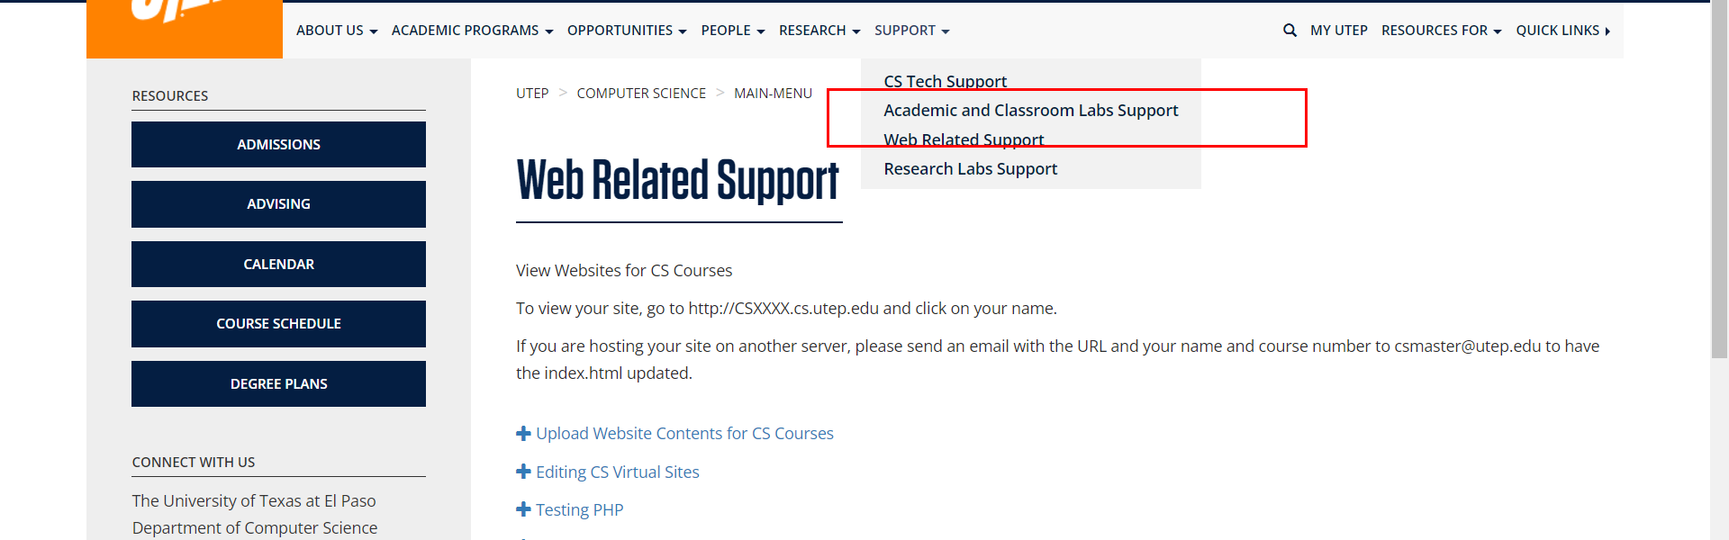

• Broken link on <https://www.utep.edu/cs/main-menu/Research.html> on **Main Navigation, tab name: Support** section, the broken link is displayed as: **Research Labs Support** and the link is pointing to : <https://www.utep.edu/cs/main-menu/Web%20Related.html>

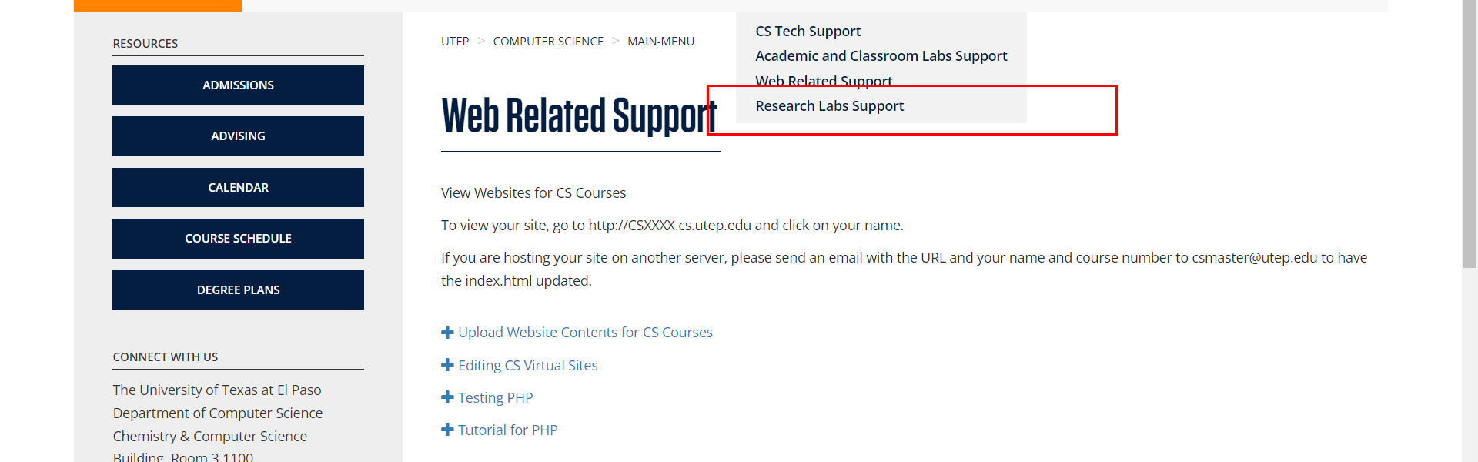

• Broken link on <https://www.utep.edu/cs/main-menu/Research.html> on **Main Navigation, tab name: People** section, the broken link is displayed as: **Teacher Assistants** and the link is pointing to : <https://www.utep.edu/cs/people/teaching-assistant.html>

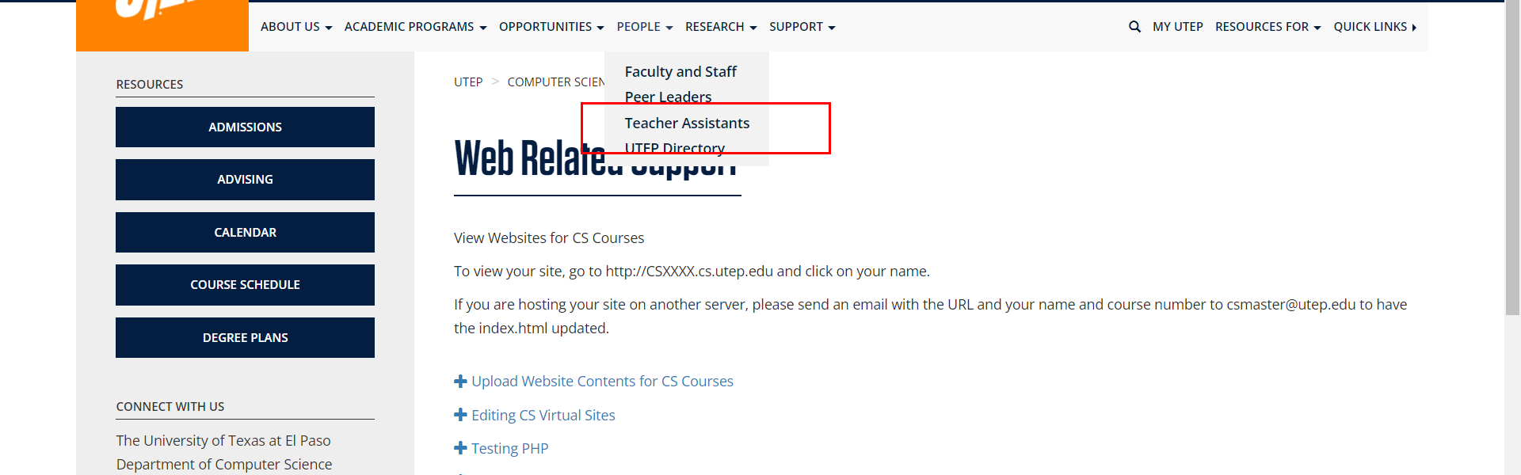

• Broken link on <https://www.utep.edu/cs/main-menu/Research.html> on **Main Navigation, tab name: People** section, the broken link is displayed as: **Peer Leaders** and the link is pointing to : <https://www.utep.edu/cs/people/PeerLeaders.html>

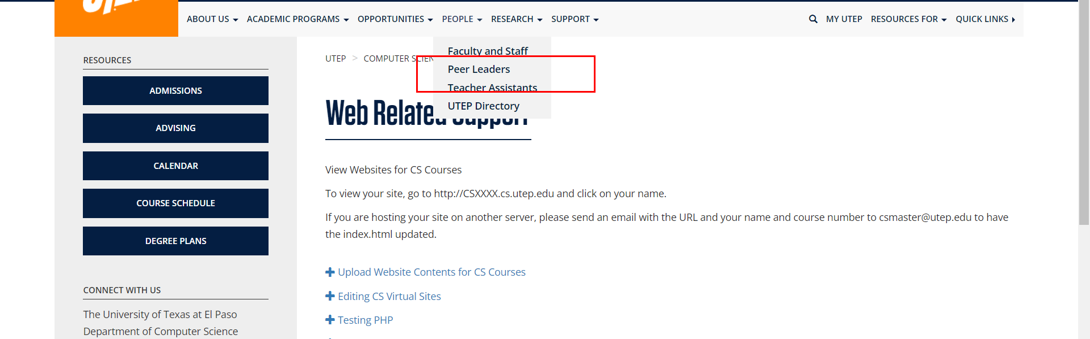

• Broken link on <https://www.utep.edu/cs/main-menu/Research.html> on **Main Navigation, tab name: Research** section, the broken link is displayed as: **Research Centers** and the link is pointing to : <https://www.utep.edu/cs/Research/Research_Centers.html>

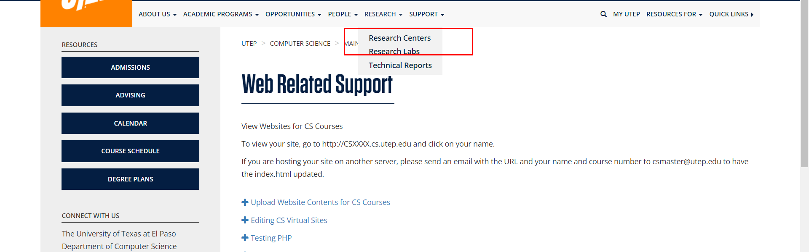

• Broken link on <https://www.utep.edu/cs/main-menu/Research.html> on **Main Content (Top small navigation)** section, the broken link is displayed as: **Main-menu** and the link is pointing to : <https://www.utep.edu/cs/Main-menu/>



• Broken link on <https://www.utep.edu/cs/main-menu/Research.html> on **Left Navigation** section, the broken link is displayed as: **Calendar** and the link is pointing to : <https://www.utep.edu/cs/Opportunities/calendar.html>

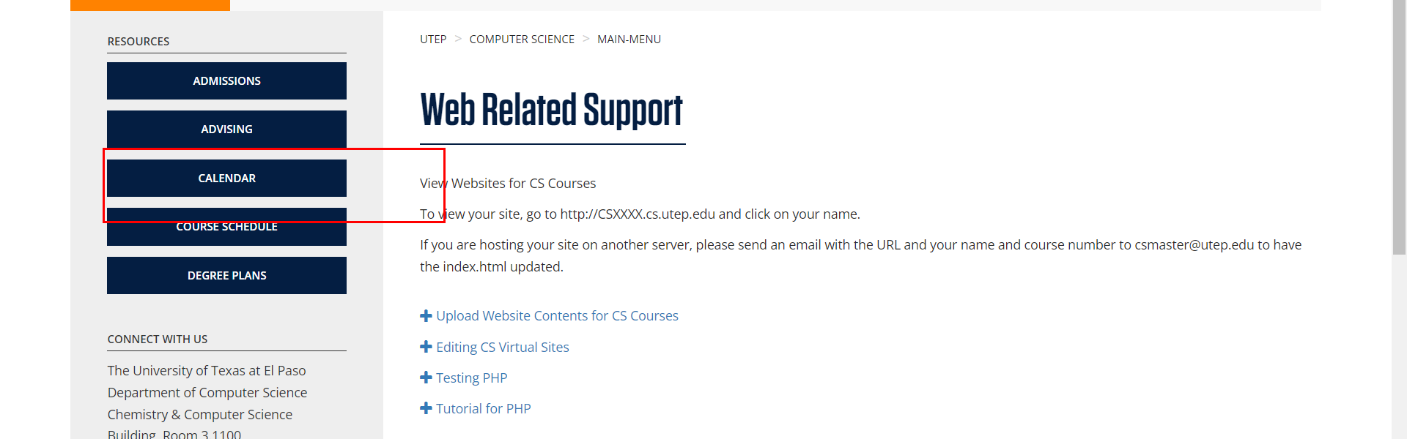

• Broken link on <https://www.utep.edu/cs/main-menu/Research.html> on **Left Navigation** section, the broken link is displayed as: **Course Schedule** and the link is pointing to : <https://www.utep.edu/cs/main-menu/CourseSchedule.html>

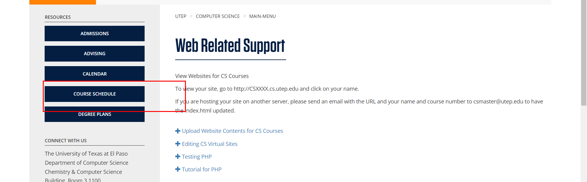

• Broken link on <https://www.utep.edu/cs/main-menu/Research.html> on **Left Navigation** section, the broken link is displayed as: **Degree Plans** and the link is pointing to : <https://www.utep.edu/cs/main-menu/DegreePlans.html>

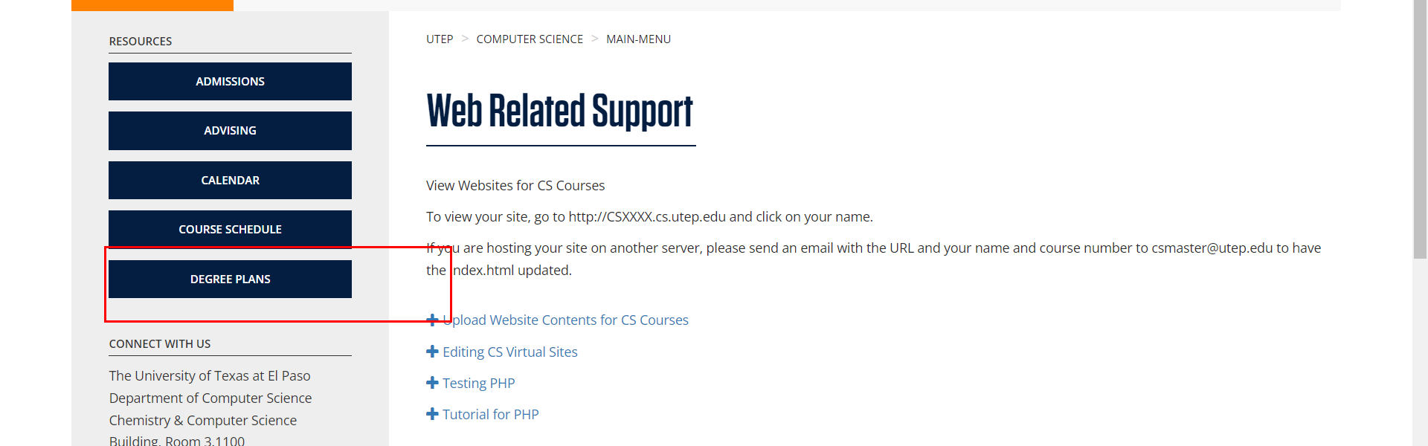

• Broken link on <https://www.utep.edu/cs/main-menu/Research.html> on **Left Navigation** section, the broken link is displayed as: **Advising** and the link is pointing to : <https://www.utep.edu/cs/main-menu/Advising.html>

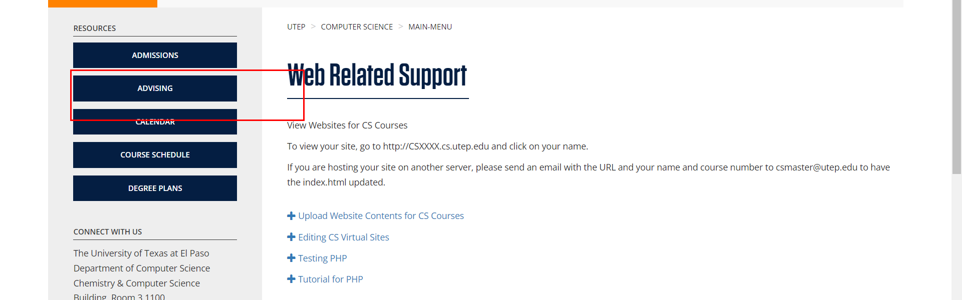

• Broken link on <https://www.utep.edu/cs/main-menu/Research.html> on **Left Navigation** section, the broken link is displayed as: **Admissions** and the link is pointing to : <https://www.utep.edu/cs/main-menu/Admissions.html>



• Broken link on <https://www.utep.edu/cs/main-menu/scholarships.html> on **Somewhere unknown** section, the broken link is displayed as: **People** and the link is pointing to : <https://www.utep.edu/cs/people/faculty_and_staff.html>

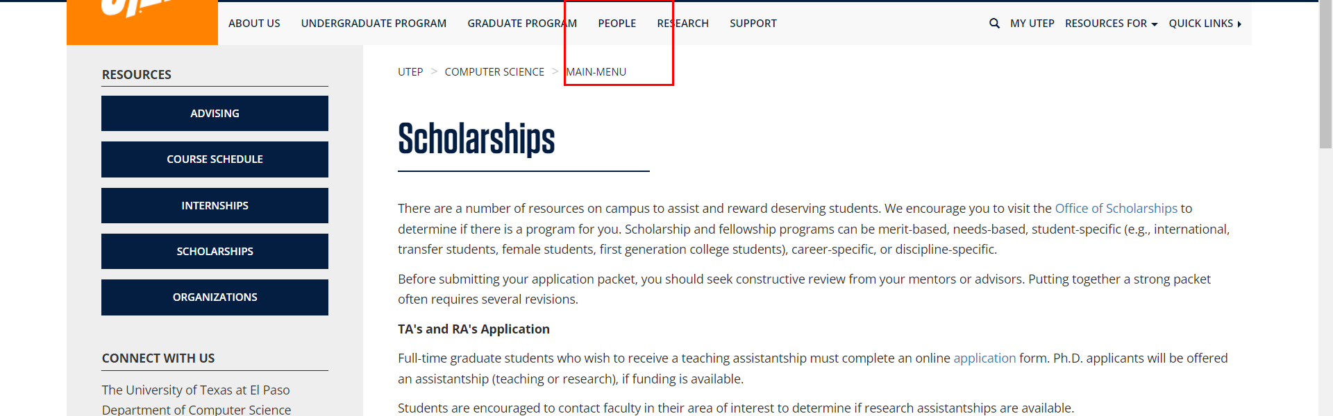

• Broken link on <https://www.utep.edu/cs/main-menu/scholarships.html> on **Main Content (Top small navigation)** section, the broken link is displayed as: **main-menu** and the link is pointing to : <https://www.utep.edu/cs/main-menu/>

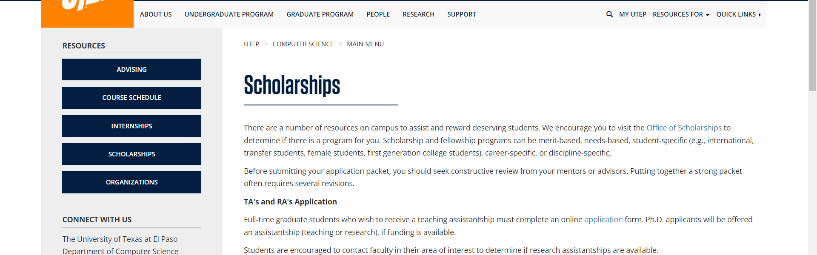

• Broken link on <https://www.utep.edu/cs/main-menu/scholarships.html> on **Somewhere unknown** section, the broken link is displayed as: **Research** and the link is pointing to : <https://www.utep.edu/cs/research/research_centers.html>

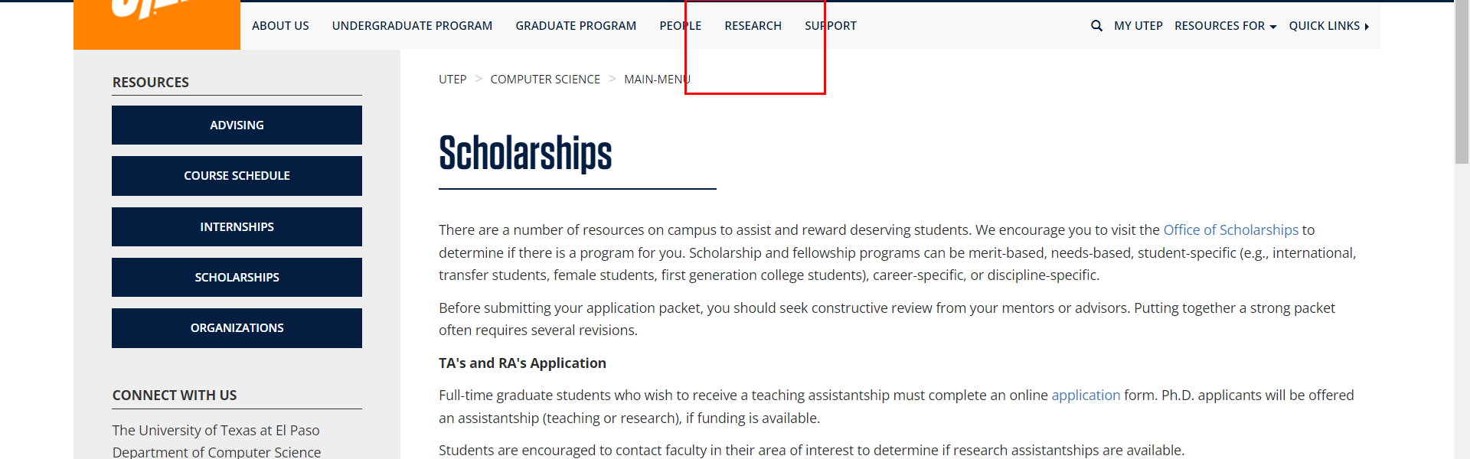

• Broken link on <https://www.utep.edu/cs/main-menu/scholarships.html> on **Main Content** section, the broken link is displayed as: **S-STEM scholarship** and the link is pointing to : <https://www.utep.edu/cs/main-menu/s-stem_scholarship_program.html>

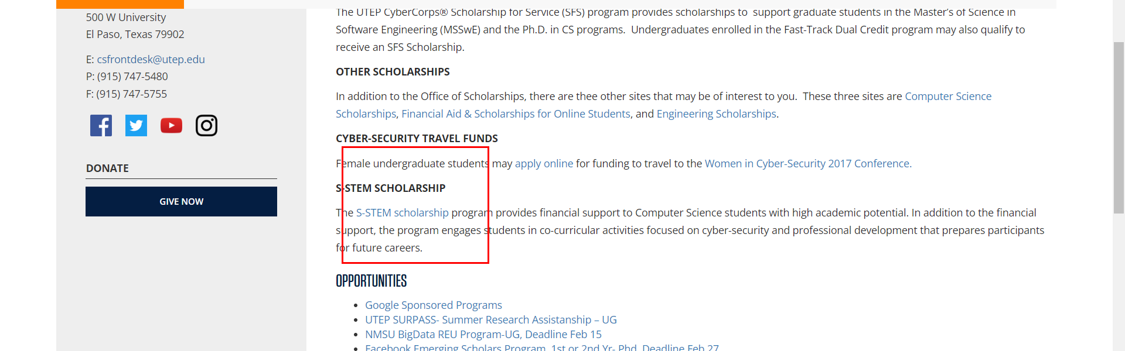

• Broken link on <https://www.utep.edu/cs/main-menu/scholarships.html> on **Left Navigation** section, the broken link is displayed as: **Advising** and the link is pointing to : <https://www.utep.edu/cs/main-menu/advising.html>

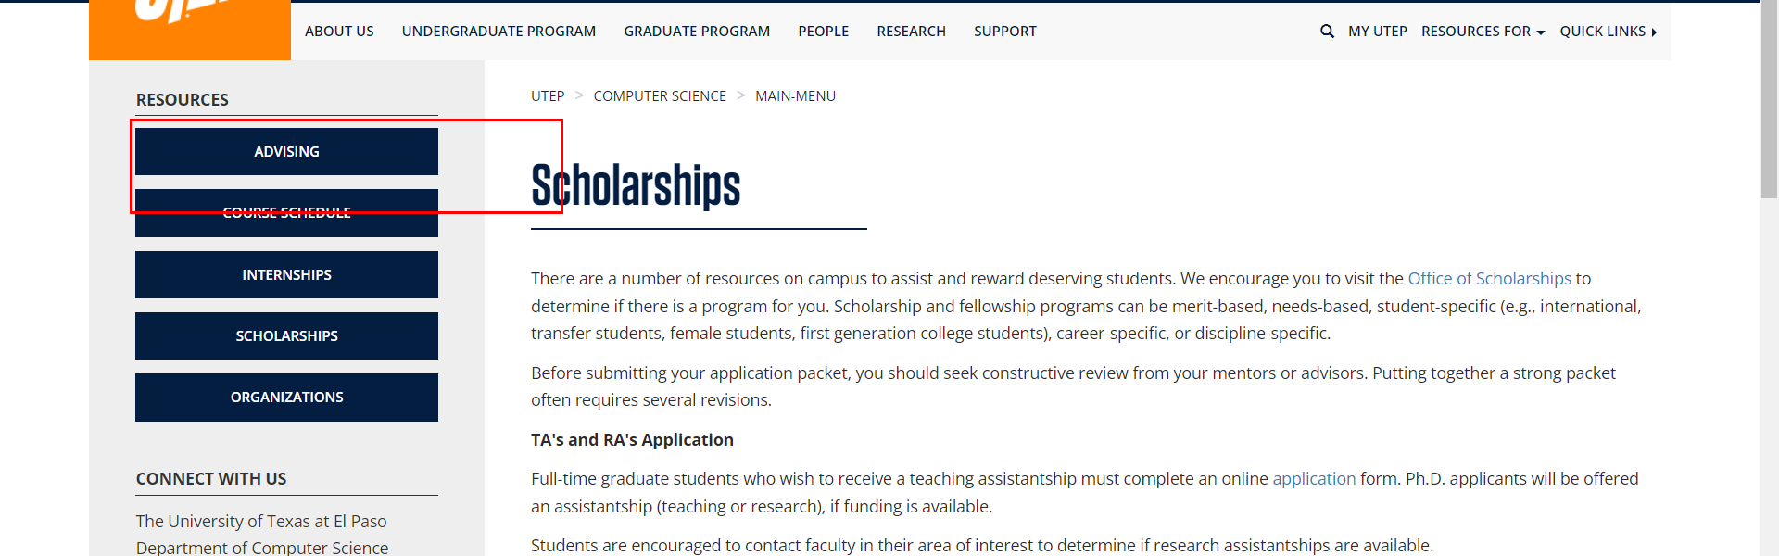

• Broken link on <https://www.utep.edu/cs/main-menu/scholarships.html> on **Main Content** section, the broken link is displayed as: **Women in Cyber-Security 2017 Conference.** and the link is pointing to : <http://www.wicys.net/>

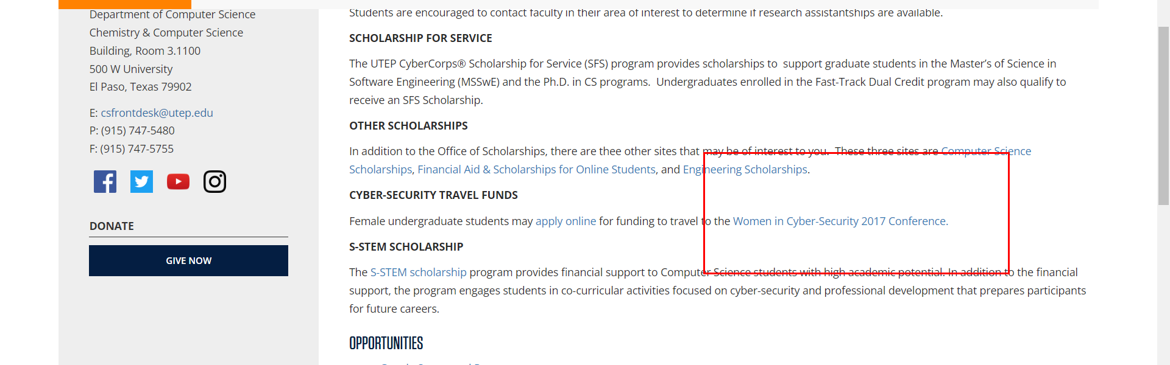

• Broken link on <https://www.utep.edu/cs/main-menu/scholarships.html> on **Left Navigation** section, the broken link is displayed as: **Organizations** and the link is pointing to : <https://www.utep.edu/cs/main-menu/organizations.html>

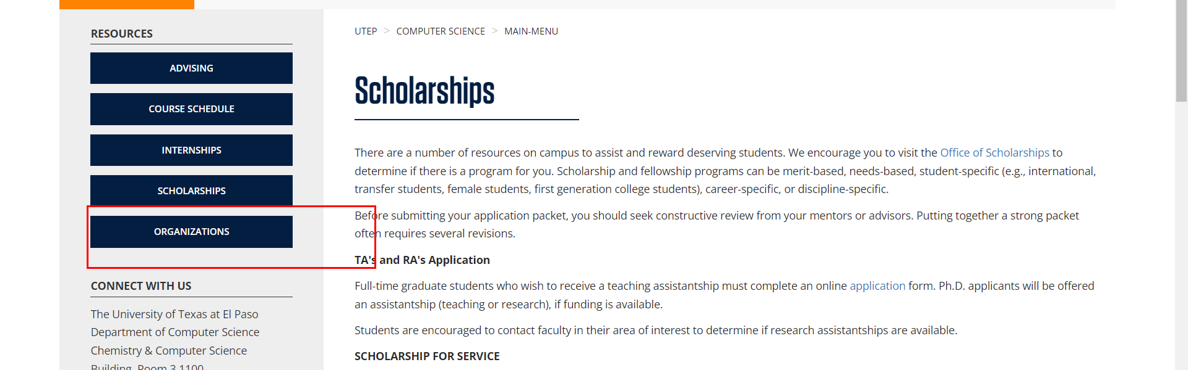

• Broken link on <https://www.utep.edu/cs/main-menu/scholarships.html> on **Left Navigation** section, the broken link is displayed as: **Internships** and the link is pointing to : <https://www.utep.edu/cs/main-menu/internships.html>

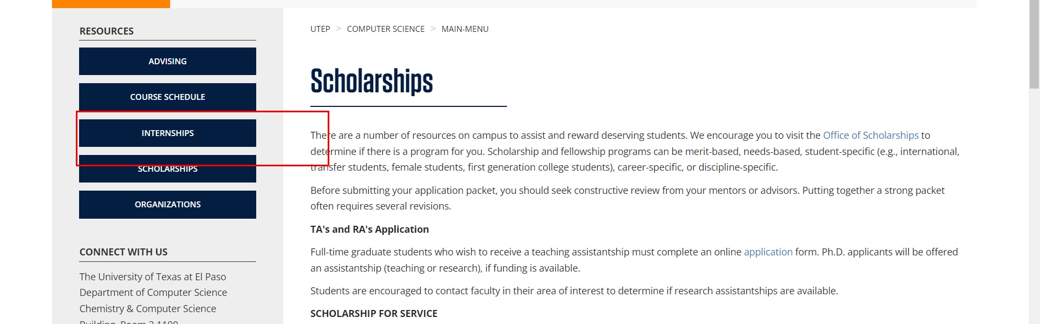

• Broken link on <https://www.utep.edu/cs/main-menu/scholarships.html> on **Main Content** section, the broken link is displayed as: **HENAAC Conference Scholarship, UG and GR** and the link is pointing to : <https://greatmindsinstem.org/college/scholarship-application-information>

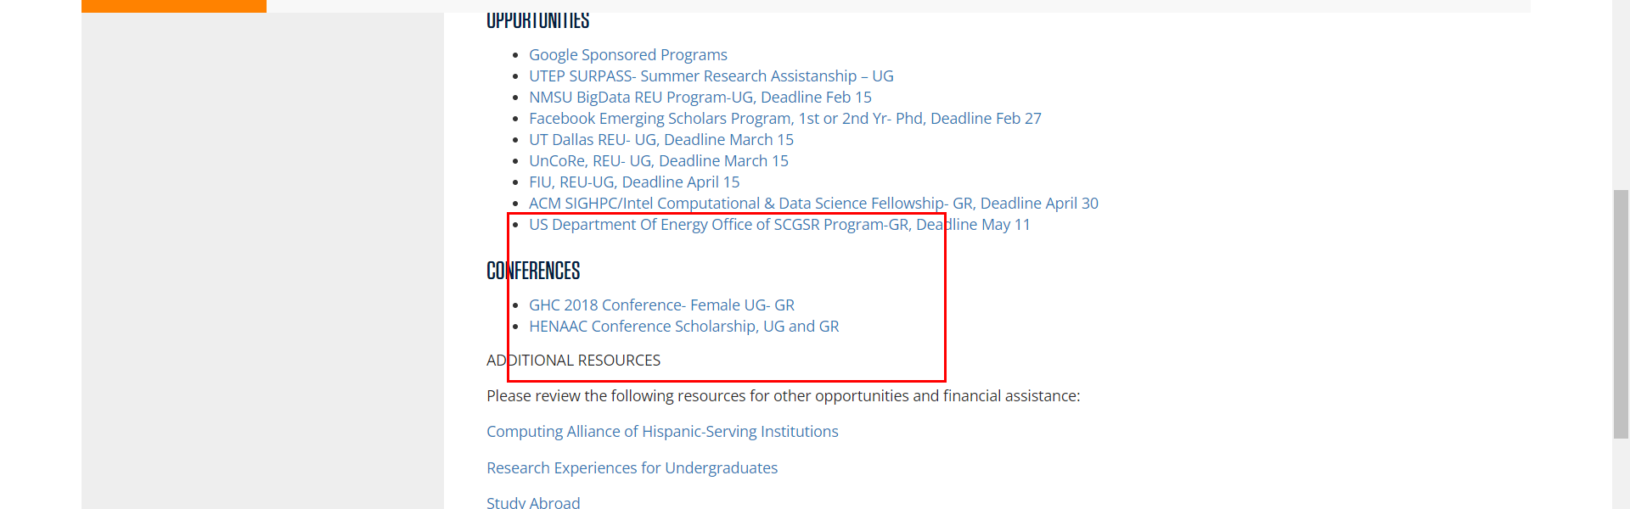

• Broken link on <https://www.utep.edu/cs/main-menu/scholarships.html> on **Left Navigation** section, the broken link is displayed as: **Give Now** and the link is pointing to : <https://www.utep.edu/entity/open.act?type=symlink&id=1a2ffcaf816c09bf244acb94b5b6fadd>

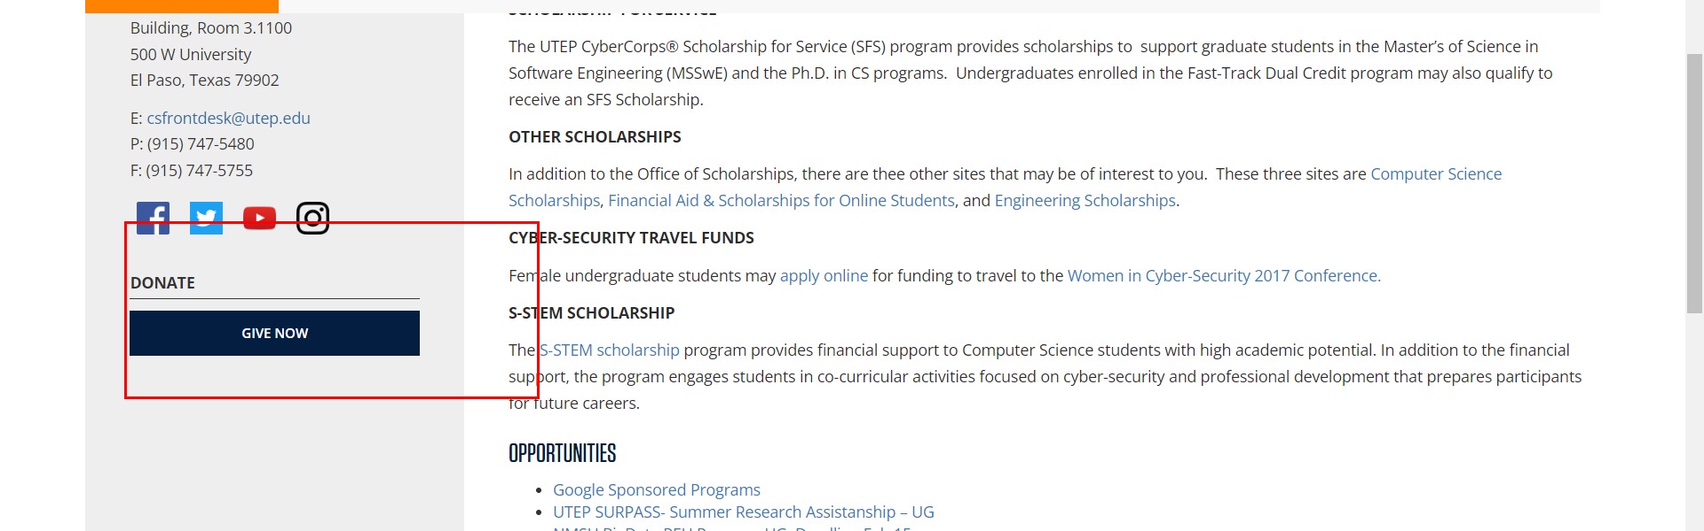

• Broken link on <https://www.utep.edu/cs/main-menu/sfs_application.html> on **Somewhere unknown** section, the broken link is displayed as: **Research** and the link is pointing to : <https://www.utep.edu/cs/research/research_centers.html>

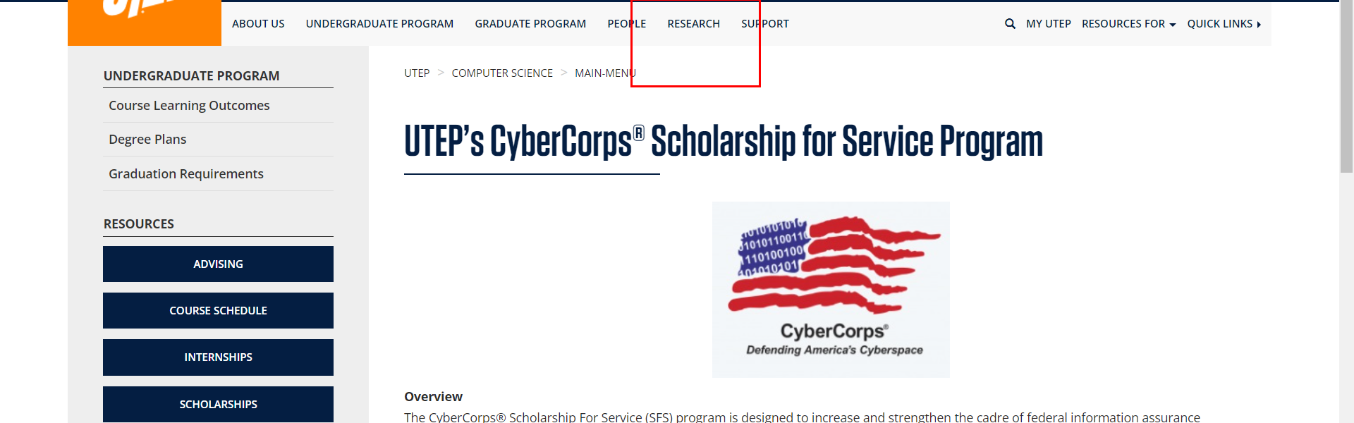

• Broken link on <https://www.utep.edu/cs/main-menu/sfs_application.html> on **Main Content (Top small navigation)** section, the broken link is displayed as: **main-menu** and the link is pointing to : <https://www.utep.edu/cs/main-menu/>

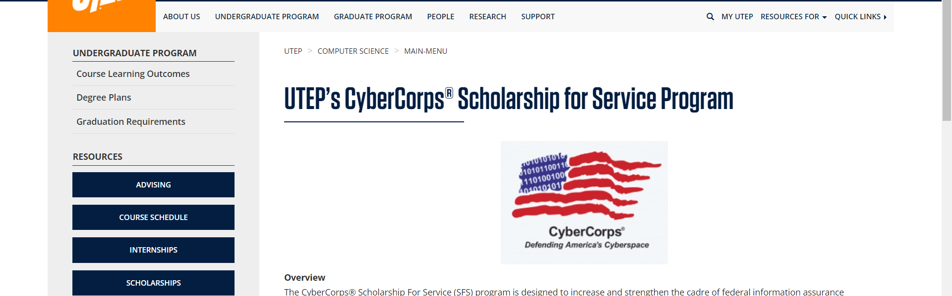

• Broken link on <https://www.utep.edu/cs/main-menu/sfs_application.html> on **Main Content** section, the broken link is displayed as: **fast-track program (BSCS/MSSwE)** and the link is pointing to : <https://www.utep.edu/graduate/_Files/docs/admission-and-enrollment/fast-track.pdf>

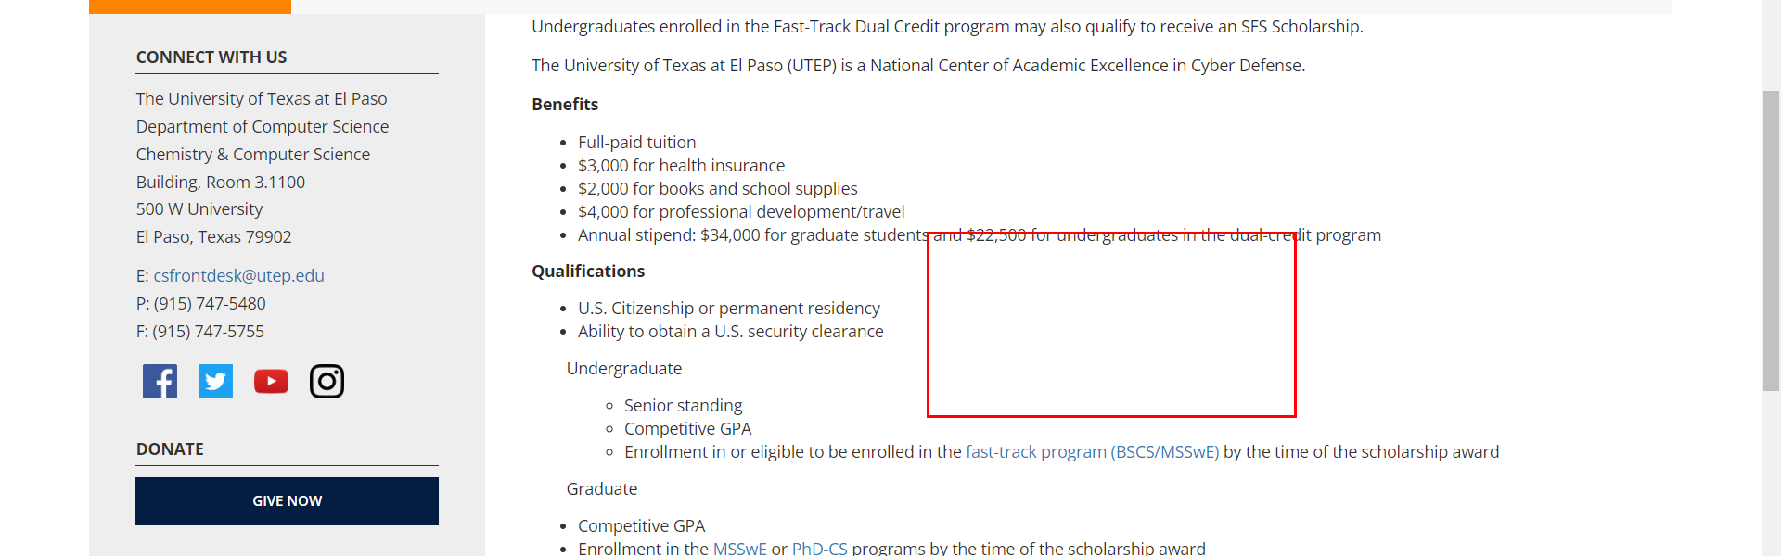

• Broken link on <https://www.utep.edu/cs/main-menu/sfs_application.html> on **Somewhere unknown** section, the broken link is displayed as: **People** and the link is pointing to : <https://www.utep.edu/cs/people/faculty_and_staff.html>

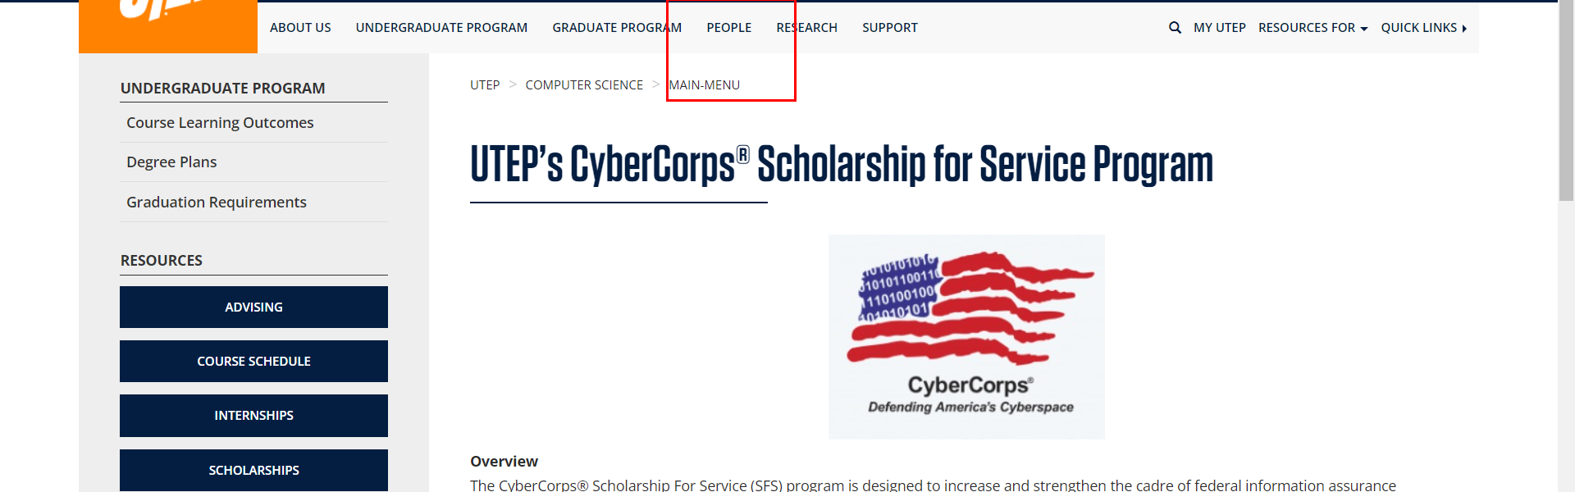

• Broken link on <https://www.utep.edu/cs/main-menu/sfs_application.html> on **Main Content** section, the broken link is displayed as: **Cybersecurity Enhancement Act of 2014 document** and the link is pointing to : <http://www.cs.utep.edu/wp-content/uploads/2016/02/PLAW-113publ274.pdf>

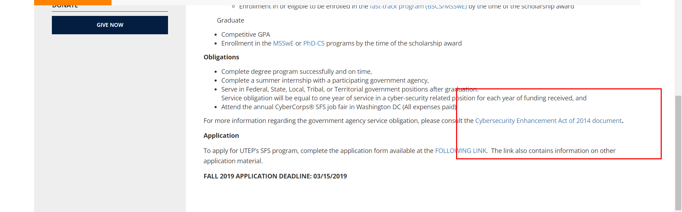

• Broken link on <https://www.utep.edu/cs/main-menu/sfs_application.html> on **Left Navigation** section, the broken link is displayed as: **Organizations** and the link is pointing to : <https://www.utep.edu/cs/main-menu/organizations.html>

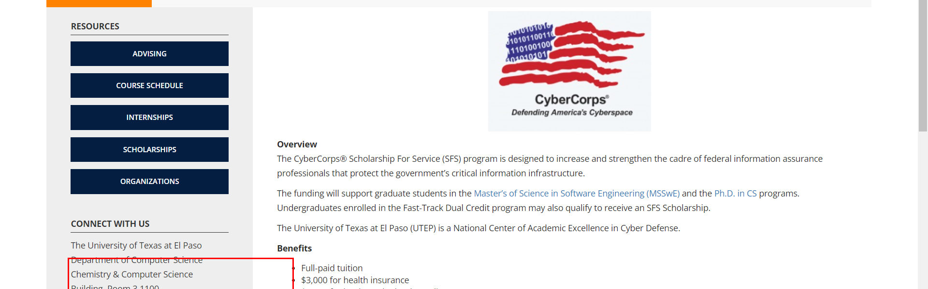

• Broken link on <https://www.utep.edu/cs/main-menu/sfs_application.html> on **Main Content** section, the broken link is displayed as: **FOLLOWING LINK** and the link is pointing to : <http://www.cs.utep.edu/utep-sfs-program/sfs-application-process/>

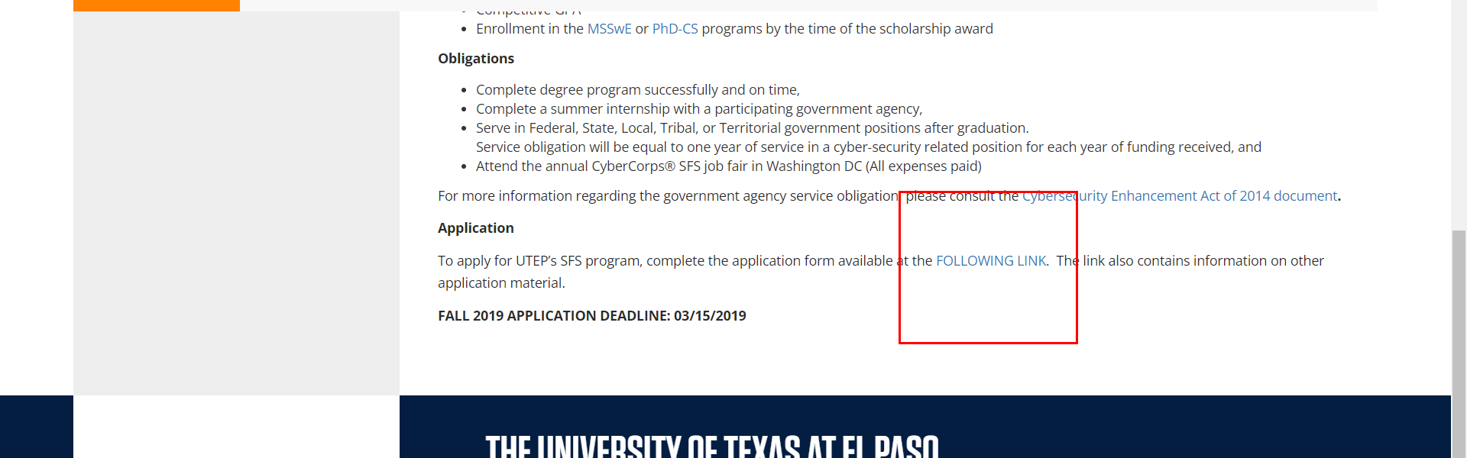

• Broken link on <https://www.utep.edu/cs/main-menu/sfs_application.html> on **Left Navigation** section, the broken link is displayed as: **Internships** and the link is pointing to : <https://www.utep.edu/cs/main-menu/internships.html>

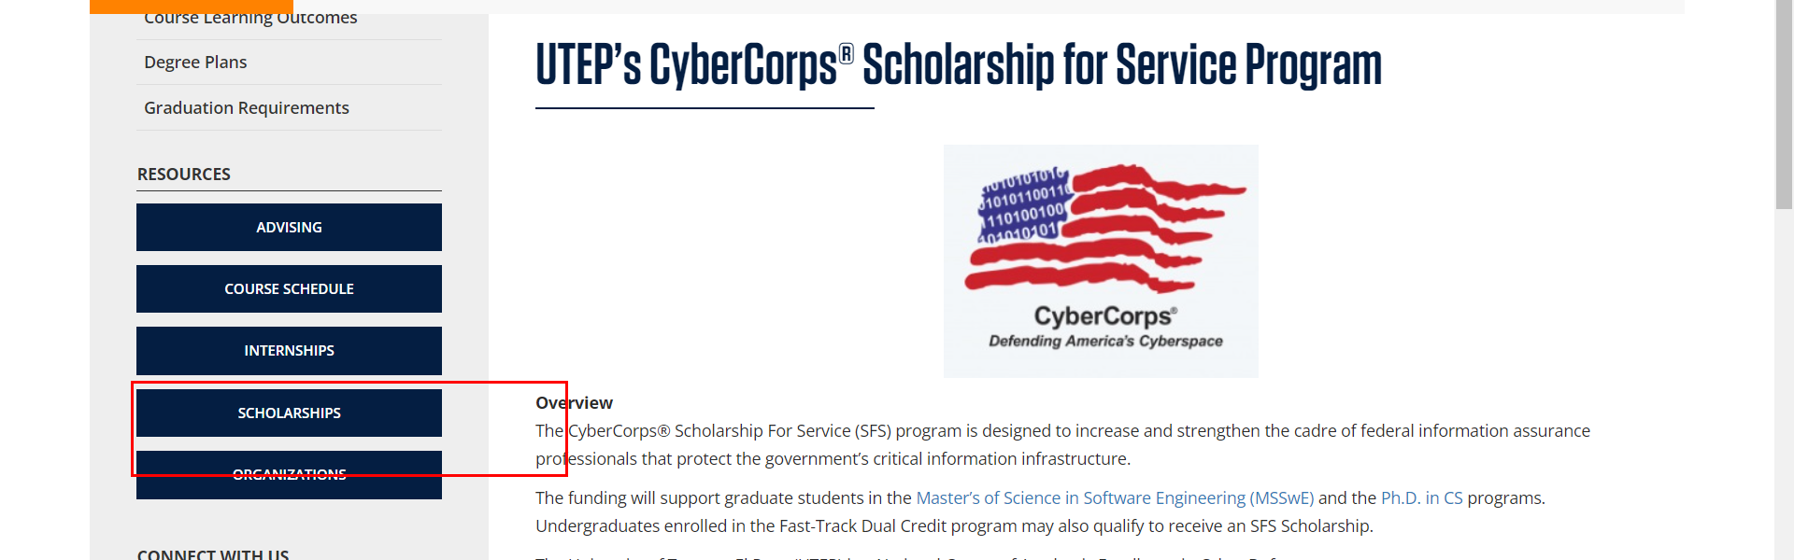

• Broken link on <https://www.utep.edu/cs/main-menu/sfs_application.html> on **Left Navigation** section, the broken link is displayed as: **Give Now** and the link is pointing to : <https://www.utep.edu/entity/open.act?type=symlink&id=1a2ffcaf816c09bf244acb94b5b6fadd>

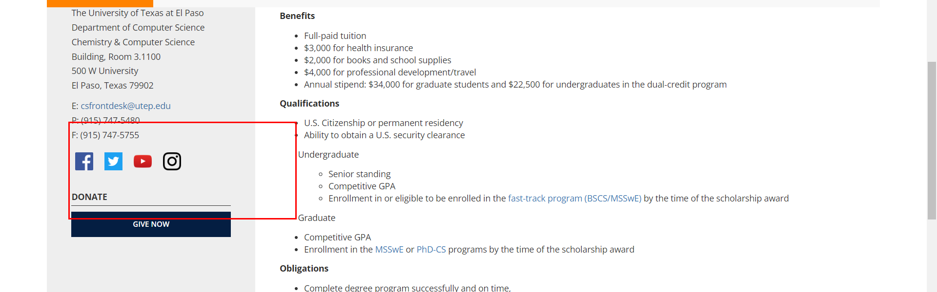

• Broken link on <https://www.utep.edu/cs/main-menu/sfs_application.html> on **Left Navigation** section, the broken link is displayed as: **Advising** and the link is pointing to : <https://www.utep.edu/cs/main-menu/advising.html>

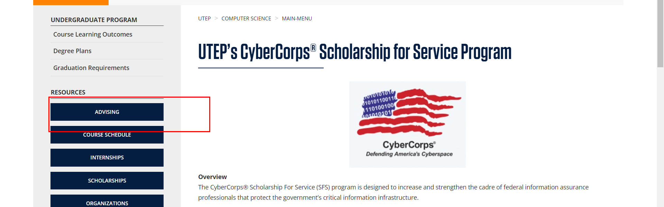

• Broken link on <https://www.utep.edu/cs/main-menu/sfs_program.html> on **Somewhere unknown** section, the broken link is displayed as: **People** and the link is pointing to : <https://www.utep.edu/cs/people/faculty_and_staff.html>



• Broken link on <https://www.utep.edu/cs/main-menu/sfs_program.html> on **Somewhere unknown** section, the broken link is displayed as: **Research** and the link is pointing to : <https://www.utep.edu/cs/research/research_centers.html>



• Broken link on <https://www.utep.edu/cs/main-menu/sfs_program.html> on **Main Content (Top small navigation)** section, the broken link is displayed as: **main-menu** and the link is pointing to : <https://www.utep.edu/cs/main-menu/>



• Broken link on <https://www.utep.edu/cs/main-menu/sfs_program.html> on **Main Content** section, the broken link is displayed as: **fast-track program (BSCS/MSSwE)** and the link is pointing to : <https://www.utep.edu/graduate/_Files/docs/admission-and-enrollment/fast-track.pdf>



• Broken link on <https://www.utep.edu/cs/main-menu/sfs_program.html> on **Main Content** section, the broken link is displayed as: **FOLLOWING LINK** and the link is pointing to : <http://www.cs.utep.edu/utep-sfs-program/sfs-application-process/>



• Broken link on <https://www.utep.edu/cs/main-menu/sfs_program.html> on **Left Navigation** section, the broken link is displayed as: **Internships** and the link is pointing to : <https://www.utep.edu/cs/main-menu/internships.html>



• Broken link on <https://www.utep.edu/cs/main-menu/sfs_program.html> on **Main Content** section, the broken link is displayed as: **Cybersecurity Enhancement Act of 2014 document** and the link is pointing to : <http://www.cs.utep.edu/wp-content/uploads/2016/02/PLAW-113publ274.pdf>



• Broken link on <https://www.utep.edu/cs/main-menu/sfs_program.html> on **Left Navigation** section, the broken link is displayed as: **Advising** and the link is pointing to : <https://www.utep.edu/cs/main-menu/advising.html>



• Broken link on <https://www.utep.edu/cs/main-menu/sfs_program.html> on **Left Navigation** section, the broken link is displayed as: **Give Now** and the link is pointing to : <https://www.utep.edu/entity/open.act?type=symlink&id=1a2ffcaf816c09bf244acb94b5b6fadd>



• Broken link on <https://www.utep.edu/cs/main-menu/sfs_program.html> on **Left Navigation** section, the broken link is displayed as: **Organizations** and the link is pointing to : <https://www.utep.edu/cs/main-menu/organizations.html>

